CHAPTER 1 INTRODUCTION

CHAPTER 1 INTRODUCTION

Objective

In recent years, the healthcare sector has been changing rapidly. It is moving from a focus on treatment to a focus on prediction and prevention. Traditional methods usually diagnose diseases only after symptoms appear or a patient's condition worsens. This delayed response can increase medical risks, treatment costs, and patient suffering. To address these issues, modern healthcare is now using smart technologies that can continuously monitor patient conditions, identify medical patterns, and provide early warnings before a disease becomes critical. One of the most promising technologies is the digital twin, a virtual version of a real-world entity that updates itself with real-time and historical data. In healthcare, a digital twin can serve as a dynamic digital replica of a patient by gathering information such as heart rate, blood pressure, glucose level, oxygen saturation, temperature, ECG readings, cholesterol values, and lifestyle habits. When combined with artificial intelligence, this system becomes even more effective, as it can monitor current health conditions and predict future risks, supporting better medical decisions.
The project, AI-Driven Digital Twin Health Monitor, aims to create a smart healthcare framework that builds a virtual health model of a patient and updates it with incoming health data. The goal is to enhance patient care through early disease prediction, ongoing observation, personalized health assessments, and simulation-based analysis. Unlike traditional monitoring systems that simply show current readings, this project applies machine learning algorithms to uncover hidden health patterns and estimate the risk of diseases like diabetes, hypertension, heart disease, and stroke. The digital twin generated in this system

acts as a personalized model that reflects the real patient’s health condition, helping to understand how that condition might progress in the future. This makes the system valuable not just for monitoring but also for forecasting, prevention, and personalized treatment planning.
The need for such a system has grown due to the increase in chronic diseases, sedentary lifestyles, stress-related disorders, and the demand for remote healthcare services. Many patients cannot regularly visit hospitals, and doctors often lack continuous health data between appointments. This situation creates gaps in care and makes it harder to detect deteriorating health early. An AI-driven digital twin health monitor can bridge this gap by allowing continuous health observation from anywhere. It supports telemedicine, home-based care, elderly care, and long-term disease management. Since the system collects and analyzes patient data over time, it can offer meaningful insights about trends, sudden changes, and gradual risk development. This helps both doctors and patients make timely, informed decisions. Additionally, such a system can lessen the burden on hospitals, improve preventive care, and contribute to a smarter, more connected healthcare ecosystem.
Another key advantage of the proposed system is its capability to perform what-if simulations and predictive analysis. This feature allows the system to analyze how a patient's future health status may change based on adjustments in medical or lifestyle factors. For instance, it can predict how controlling glucose levels might lower risk, how improving blood pressure could affect heart disease likelihood, or how rising cholesterol could influence long-term cardiovascular risk. This simulation capability makes the project more effective than a basic health dashboard, as it encourages proactive intervention rather than passive observation. It helps identify potential medical risks before they escalate and promotes timely lifestyle adjustments, medical consultations, and preventive treatments.
Overall, the AI-Driven Digital Twin Health Monitor offers a modern approach to next-generation healthcare. It combines digital representation, real- time data monitoring, machine learning predictions, and simulation-based decision support into a single platform. This project is very relevant in today’s medical landscape because it promotes personalized healthcare, remote patient monitoring, early diagnosis, and preventive treatment planning. It also opens doors for future integration with wearable devices, IoT sensors, cloud-based medical platforms, and explainable AI tools. Therefore, this project serves not only as a technical solution but also as a practical contribution to intelligent, efficient, and patient-centered healthcare systems. It aims to improve safety, reduce medical risks, and enhance quality of life by making healthcare more predictive, responsive, and data-driven.
The main goal of this project involves creating an advanced health monitoring system which builds a digital patient model through continuous tracking of present and past medical information. The digital twin functions as a digital patient model which updates its health status when new information becomes accessible. The project aims to achieve its goals through this objective which provides a comprehensive view of patient health by using ongoing health data instead of relying on single medical reports and sporadic hospital visits. The system enables ongoing patient monitoring through its virtual model which enhances medical tracking efficiency.
The second objective of this work is to integrate artificial intelligence and machine learning techniques for early disease prediction and health-risk analysis. The system needs to examine crucial health indicators which include heart rate and blood pressure and glucose level and oxygen saturation and cholesterol and BMI and medical history data to discover concealed patterns which help estimate

disease risks for diabetes and hypertension and heart disease and stroke. The objective of this project serves two functions because it transforms healthcare from a traditional reactive method into a modern approach which can detect health issues before they develop into serious conditions. The project aims to enhance early medical diagnosis processes while enabling doctors to provide essential health services at the right moment.
The project aims to create a simulation-based what-if analysis tool that will predict upcoming health scenarios. The system needs to show the current health situation of patients while predicting their future health changes based on various medical and lifestyle improvements and deteriorations. The program evaluates how blood sugar reduction and blood pressure management and cholesterol level improvement will affect future disease outcomes. The system enables doctors and patients to see potential future results which make it more effective for preventive care and personalized treatment development and healthcare decision support.
The proposed system will create a dashboard and decision-support system which will enable healthcare professionals and caregivers and patients to navigate its functions easily. The system should present health trends, alerts, predictions, and recommendations in a clear and understandable form through graphs, indicators, and summary reports. The project will develop capabilities for remote patient monitoring and telemedicine services and extended health management. The project aims to develop an intelligent healthcare solution which scales effectively and operates in real-world settings by integrating digital twin systems with AI-based predictions and simulation assessments and visualization tools to enhance patient safety and treatment development and preventive healthcare methods.

Divisions related to the project

In today's healthcare environment, patient monitoring is often limited, fragmented, and reactive. Most traditional systems rely on periodic hospital visits, manual observations, or isolated test results. This means that patient health is evaluated only at specific moments instead of being monitored continuously. As a result, many changes in a patient’s condition go unnoticed until symptoms become severe or complications develop. This is especially risky for individuals with chronic diseases like diabetes, hypertension, cardiovascular disorders, and respiratory illnesses, where early changes in health indicators can signal important warnings. Conventional healthcare systems usually cannot track these changes in real time, identify long-term health trends, or predict future risks before the disease worsens. Consequently, delayed diagnoses, poor follow-ups, lack of preventive care, and increased treatment burdens have become significant challenges in modern healthcare management.
Another major issue is that existing health monitoring applications primarily focus on showing current medical values rather than understanding the patient’s overall condition. Many systems can display readings like heart rate, blood pressure, glucose levels, or oxygen saturation, but they do not create a connected digital model of the patient that can continuously evolve with new data. They also do not combine historical records, current measurements, lifestyle factors, and predictive analysis into one cohesive framework. Due to this shortcoming, doctors and patients might not see the full picture of how a person’s condition is changing over time or what could happen in the future if the current trend continues. In everyday medical practice, this lack of continuous, personalized, and predictive monitoring limits the ability to prevent disease progression early on and makes healthcare more reliant on treatment after complications arise. Additionally, there is a lack of simulation and decision-support tools in most conventional systems. Current healthcare tools rarely offer a way to test how
changes in health indicators may impact future medical risks. For instance, they might not estimate how lowering blood sugar, improving cholesterol levels, or changing blood pressure could influence the risk of heart disease or stroke. Without this what-if analysis, healthcare remains mostly observational instead of being predictive and preventive. This becomes a serious concern in remote patient monitoring, telemedicine, elderly care, and chronic disease management, where doctors need intelligent tools to make better decisions even when the patient is not physically in the hospital. The absence of such analytical support limits personalized care planning and reduces the overall effectiveness of healthcare delivery.
The first major division related to the project is the Health Data Acquisition Division. The division collects all patient data which medical personnel require to establish and maintain the digital twin system. The system provides health parameters which include heart rate and blood pressure and glucose level and oxygen saturation and body temperature and cholesterol and ECG readings and BMI and age and medical history and lifestyle details. The overall system accuracy relies on this division because it needs high-quality input data for meaningful analysis and prediction. The division collects information through hospital records and wearable sensors and diagnostic devices and online health portals and manual input from patients and healthcare professionals.
The second important division is the Digital Twin Modeling Division. The division develops and operates a digital twin of the patient which uses health information that has been collected. The system represents the principal component of the project because it transforms basic medical data into an active patient system which continuously updates. The division updates the digital twin whenever new health information becomes available to show the actual status of the patient. The system organizes current measurements with past data and health trends to create a complete digital health record which it maintains for each individual patient.

The third major division is the Artificial Intelligence and Prediction Division applies machine learning algorithms combined with analytical methods to investigate a patient's digital twin which allows the discovery of hidden health information. The organization specializes in forecasting potential illnesses while determining the diabetes hypertension heart disease and stroke risk for chronic health problems. The project gains advanced capabilities through this division which enables its transition from basic monitoring to intelligent forecasting functions. The system achieves higher active performance through its capacity to create early warnings and conduct individual risk evaluations and offer preventive health care suggestions.
The fourth division is the Simulation, Visualization, and Decision Support Division. The division uses dashboards, graphs, alerts, and reports to present results which doctors, caregivers, and patients can easily understand to evaluate health conditions. The system conducts what-if analysis to demonstrate how particular medical conditions and lifestyle factors will affect future health outcomes. The system can predict future disease risk based on blood sugar control and blood pressure reduction. The division enables users to make better decisions while conducting remote patient monitoring and developing treatment plans through its simple interface design.

Contributions of the work
The AI-Driven Digital Twin Health Monitor system establishes crucial advancements for intelligent healthcare systems through its unified platform which monitors patients and creates virtual models and employs artificial intelligence and predictive analytics technologies. The first major contribution of this work is the creation of a digital twin of the patient, which acts as a continuously updated virtual representation of the real individual. The digital twin

system creates a health profile that updates in real time because it uses physiological data together with clinical information and lifestyle data instead of maintaining separate health records. The second contribution is the integration of AI and machine learning techniques for early disease-risk prediction. The system analyzes health parameters which include heart rate blood pressure glucose level cholesterol oxygen saturation BMI and medical history to identify abnormal patterns that predict diabetes and hypertension and heart disease and stroke at their early stages. The system helps healthcare providers deliver preventative care instead of offering reactive medical treatment.
The research introduces a new simulation and what-if analysis system which enables the system to examine future health condition changes through patient parameter improvements and degenerations. The system uses this functionality to predict future outcomes through blood pressure changes and glucose level changes and cholesterol level changes and body weight changes and other key variable changes. The project establishes a real-time health visualization system that displays risk levels and health trends and emergency alerts and medical recommendations in understandable formats for doctors and caregivers and patients.
The first major contribution of this work is the development of a patient-specific digital twin model for healthcare monitoring. The traditional system manages patient information through separate storage of distinct records and reports and device readings which do not create an ongoing virtual patient model. The project produces a digital twin which functions as a permanent digital duplicate of the patient that uses health data which includes heart rate and blood pressure and glucose level and oxygen saturation and body temperature and cholesterol and BMI and ECG results and medical history. The virtual patient model enables the system to present an organized health condition overview which shows how the patient’s health status changes throughout different time periods.

The second important contribution of this work is the integration of artificial intelligence and machine learning into the healthcare monitoring process. The proposed system uses advanced patient data analysis methods to detect hidden medical patterns which manual observation cannot easily identify instead of displaying health values through a screen. The system uses trained predictive models to predict the probability of diabetes and hypertension and heart disease and stroke development. The research transforms healthcare from a reactive approach which starts treatment after symptoms develop into a proactive approach which enables early identification of potential health risks. The project develops essential intelligence and decision-making support functions which enhance conventional health monitoring systems.
The research work presents its third contribution through the development of continuous health monitoring system which provides personalized health monitoring for each individual. Existing systems often provide generalized alerts or threshold-based warnings that are the same for all patients. This project develops a patient-centered monitoring system which analyzes individual health data and medical history and ongoing physiological changes. The personalized method used in this evaluation process provides better results because it assesses individual health differences among patients. The system now suits chronic disease management needs and elderly care requirements and home monitoring needs and telemedicine requirements which need continuous tracking of patient health information.
The fourth major contribution is the inclusion of a simulation and what-if analysis mechanism. The project gains advanced status through this feature which extends beyond standard health dashboards that only monitor current operations.
The system estimates how future disease risk will change when blood sugar levels decrease and blood pressure control improves and cholesterol levels drop and physical activity increases. The predictive simulation system enables preventive healthcare through its ability to assist doctors and patients in understanding the probable outcomes of medical treatment and lifestyle modifications before actual health problems develop. The project enables organizations to perform observation functions while obtaining future data which helps them create strategic plans.
The interactive visualization together with the decision-support dashboard provides healthcare analysis through its first contribution to this research. Medical data is often complex and difficult for patients or even healthcare workers to interpret quickly when it is scattered across different reports. The project shows health information through graphs and risk indicators together with alerts and summary views which make it easier to track the patient´s present situation and future danger. The dashboard enhances communication between the doctor and patient while it enables doctors to make faster decisions and do better patient monitoring from a distance. The system gains better usability because it transforms specialized medical research results into user-friendly content that people can easily understand.
The unified framework which this research provides as its sixth contribution establishes a complete system for upcoming intelligent medical treatment technologies. The project combines health data acquisition, secure preprocessing, digital twin modeling, AI-based disease prediction, simulation analysis, and visualization into a single integrated platform. The complete system design of this solution provides important benefits because it combines multiple functions to solve five different healthcare system problems which include broken patient records together with slow patient assessments and problems with individualized treatment and the need for predictive capabilities.

CHAPTER 2 LITERATURE SURVEY

CHAPTER 2 LITERATURE SURVEY
2.1 Overview of Digital Twin Applications in Healthcare

Digital twin technology has emerged as one of the most promising innovations in healthcare, offering a paradigm shift from reactive treatment to proactive and predictive medicine. Venkatesh et al. [1] provided one of the earliest comprehensive discussions on health digital twins, focusing on the computational, implementation, and regulatory considerations necessary for their deployment. Their review highlighted that while digital twins hold immense potential for individualized care, their adoption requires robust computational frameworks capable of handling heterogeneous biomedical data, as well as clear regulatory pathways to ensure patient safety and ethical compliance. This foundational work established the importance of aligning technological innovation with healthcare governance, thereby setting the stage for subsequent research.

Building on this foundation, Coorey et al. [2] extended the discussion into the cardiovascular domain, presenting digital twins as interdisciplinary tools that combine engineering, medicine, and data science to tackle cardiovascular disease. Their review emphasized the clinical relevance of patient-specific cardiac twins, which can simulate disease progression, predict treatment outcomes, and support precision cardiology. By integrating computational fluid dynamics with patient imaging data, these twins demonstrated how digital replicas could be used to optimize interventions such as stent placement or valve repair. However, the authors also noted that the success of such systems depends heavily on the availability of high-quality patient data and the ability to integrate diverse datasets into coherent models.

Sun et al. [3] framed digital twins as a key to the future of healthcare, emphasizing their potential to revolutionize clinical practice by enabling continuous monitoring and predictive analytics. Their work underscored the transformative nature of digital twins, arguing that they could serve as dynamic, evolving representations of patients that update in real time as new data becomes available. This perspective highlighted the shift from static electronic health records to living digital entities that can anticipate health risks before they manifest clinically. Yet, Sun and colleagues also cautioned that significant challenges remain, particularly in terms of data privacy, interoperability, and the ethical use of predictive models in patient care.

Elkefi and Asan [4] broadened the scope further, demonstrating how digital twins could be applied not only to individual patient care but also to healthcare system management. Their review explored applications in workflow optimization, resource allocation, and safety management, showing that digital twins could serve as decision-support tools at both the micro (patient) and macro (system) levels. By modeling hospital operations and simulating patient flow, digital twins were shown to improve efficiency, reduce bottlenecks, and enhance patient safety. This systemic perspective underscored the versatility of digital twins, suggesting that they could simultaneously address clinical, operational, and administrative challenges in healthcare.

Taken together, these early reviews [1–4] establish digital twins as a promising but still evolving paradigm in healthcare. They highlight the dual potential of digital twins: on one hand, as individualized patient models capable of guiding precision medicine, and on the other, as system-level tools for optimizing healthcare delivery. At the same time, they underscore the challenges of data integration, regulatory compliance, and ethical governance, which must be addressed before digital twins can achieve widespread clinical adoption.

2.2 Methodological Advances and Decision Support

A significant body of literature has concentrated on the methodological foundations of digital twins in healthcare, exploring how simulation, modeling, and decision-support systems can be integrated into clinical workflows. Meijer et al. [5] provided a detailed account of simulation-based what-if analysis, demonstrating how digital twins can forecast health scenarios under preventive interventions such as blood sugar reduction or blood pressure management. Their work emphasized that digital twins are not merely passive representations of patients but active computational models capable of predicting outcomes under different treatment strategies. This methodological innovation highlighted the potential of digital twins to transform preventive medicine by enabling clinicians to anticipate risks and tailor interventions before adverse events occur.

Machado and Berssaneti [6] advanced this discussion by proposing dashboard-driven decision-support systems that integrate artificial intelligence predictions with visualization tools. Their review underscored the importance of user-friendly interfaces that allow clinicians to interact with complex models without requiring advanced technical expertise. By embedding predictive analytics into dashboards, digital twins become accessible tools for telemedicine and remote monitoring, bridging the gap between computational sophistication and clinical usability. However, the authors also noted that the effectiveness of such systems depends on the quality of input data and the robustness of algorithms, pointing to the need for standardized data pipelines and validation frameworks.

Sun et al. [7] offered a more recent update on digital twin applications, focusing on the challenges of privacy, interoperability, and ethical governance. Their review highlighted that while digital twins promise unprecedented personalization, they also raise concerns about data ownership, patient consent, and the potential misuse of predictive models. This perspective reinforced the idea that methodological advances must be accompanied by ethical safeguards to ensure that digital twins enhance, rather than compromise, patient trust.

Sheng et al. [8] adopted a novel approach by applying structural topic modeling to the digital twin literature, revealing latent clusters in research themes. Their systematic review identified emerging areas such as smart hospitals, patient-specific modeling, and decision-support systems, confirming the interdisciplinary nature of digital twin research. By mapping research trends, Sheng and colleagues provided a methodological roadmap for future studies, showing where the field is converging and where gaps remain.

Vallée [9] positioned digital twins as a comprehensive monitoring framework capable of early detection of health changes. Their work emphasized the predictive power of digital twins, arguing that they could serve as continuous health monitors that alert clinicians to subtle physiological changes before they escalate into clinical crises. This methodological perspective reinforced the role of digital twins as proactive tools in healthcare, shifting the focus from treatment to prevention.

Finally, Katsoulakis et al. [10] conducted a scoping review that mapped digital twin applications across patient care, healthcare operations, and research. Their review underscored the methodological diversity of digital twin systems, ranging from individualized patient models to system-level simulations of hospital workflows. Importantly, they highlighted the need for interdisciplinary collaboration, noting that successful digital twin implementation requires input from clinicians, engineers, data scientists, and policymakers.

Taken together, these methodological reviews [5–10] illustrate the breadth of approaches being explored in digital twin research. They highlight simulation, visualization, predictive analytics, and system-level modeling as key methodological pillars, while also underscoring the importance of ethical governance, data quality, and interdisciplinary collaboration. Collectively, they demonstrate that methodological innovation is central to the evolution of digital twins in healthcare, providing the tools and frameworks necessary for their integration into clinical practice.
2.3 Wearables, IoT, and Sensor-Based Twins
One of the most dynamic areas of digital twin research in healthcare has been the integration of wearable devices and sensor technologies. Johnson and Saikia [11] provided a comprehensive review of how wearable-driven twins can be used for circulatory and musculoskeletal monitoring. Their work highlighted the promise of real-time disease prediction, where continuous streams of physiological data from sensors are fed into digital twin models to anticipate health risks. However, they also noted that current devices remain limited in fidelity, often capturing only partial aspects of patient physiology, which restricts the accuracy of whole-body digital twins. This underscores the need for more advanced sensors and multimodal data integration to achieve clinically reliable models.
Zhang et al. [12] contributed to conceptual clarity by outlining the definitions and applications of digital twins in healthcare and medicine. They distinguished between monitoring twins, which update patient states in real time, and simulation twins, which forecast future outcomes based on predictive modeling. This distinction is crucial for wearable-driven twins, as it determines whether sensor data is used primarily for tracking current health status or for anticipating disease trajectories. Drummond et al. [13] reinforced this perspective by conducting a scoping review of patient digital twins being developed for clinical use, identifying common characteristics such as personalization, adaptability, and integration with electronic health records. Their findings highlighted that while wearable data is essential for personalization, challenges remain in standardizing data formats and ensuring interoperability across devices.
Shen et al. [14] systematically reviewed the effectiveness of digital twins in promoting precision health across populations. Their analysis showed that wearable-driven twins can enhance therapy personalization and risk prediction, but they also emphasized that evidence remains limited, with most studies confined to pilot projects or theoretical frameworks. Li et al. [15] examined the current status and future prospects of digital twins for healthcare, drawing attention to fairness and ethical concerns. They argued that wearable-driven twins risk exacerbating health inequalities if access to advanced devices is restricted to affluent populations, thereby raising questions about equity in digital health.
Sarani Rad et al. [16] introduced a patient-centric knowledge graph approach for diabetes management, demonstrating how wearable data can be structured into explainable models. By linking sensor readings with biomarkers, symptoms, and treatment pathways, their framework enhanced personalization and interpretability, addressing one of the key limitations of black-box predictive models. Zhang et al. [17] extended this work by proposing a framework for type 2 diabetes that integrates multiomics data with machine learning, showing how wearable-driven twins can be combined with molecular-level information to create comprehensive patient models. Shamanna et al. [18] provided rare outcome-oriented evidence, reporting one-year results of a digital twin intervention for diabetes. Their study demonstrated improved glycemic control and reduced medication use, offering empirical validation of wearable-driven twins in chronic disease management.
El-Warrak and Farias [19] offered a quick review of digital twin applications in health, summarizing the state of the art and identifying wearable integration as a key driver of future adoption. Łukaniszyn et al. [20] examined the role of artificial intelligence in generating digital twins for personalized healthcare, highlighting how AI can enhance the processing of sensor data to create more accurate and adaptive models. Their work pointed to the convergence of AI and IoT as a critical frontier, where wearable-driven twins evolve into intelligent systems capable of autonomous learning and adaptation.
Taken together, these reviews [11–20] demonstrate that wearable devices and IoT systems are central to the evolution of digital twins in healthcare. They highlight both the promise of real-time monitoring and the challenges of data fidelity, interoperability, and equity. While pilot studies have shown encouraging results, particularly in diabetes management, the broader adoption of wearable-driven twins will depend on advances in sensor technology, AI integration, and ethical governance.
2.4 Disease-Specific Applications
The application of digital twins in disease-specific contexts has become one of the most vibrant areas of research, particularly in chronic disease management where continuous monitoring and predictive modeling are essential. De Domenico et al. [21] explored the challenges and opportunities of digital twins in precision medicine from a complex systems perspective. Their work argued that the true potential of digital twins lies in their ability to integrate diverse data streams — ranging from genomic and proteomic information to lifestyle and environmental factors — into coherent models that can capture the multifaceted nature of disease progression. By adopting a systems-level lens, they highlighted that digital twins must move beyond isolated patient models to embrace the complexity of human health, where interactions between biological, behavioral, and social determinants shape outcomes.
Pellegrino et al. [22] synthesized evidence into a conceptual framework for digital twin adoption in healthcare, conducting a systematic meta-review that consolidated findings across multiple studies. Their framework identified common dimensions influencing integration, such as technological readiness, governance structures, and clinical validation. Importantly, they emphasized that adoption is not merely a technical challenge but also an organizational one, requiring alignment between healthcare institutions, policymakers, and technology providers. This perspective underscored the need for holistic strategies that address infrastructure, regulation, and workforce training alongside technological innovation.
Kabir et al. [23] examined digital twins in the context of healthcare IoT, conducting a systematic review that highlighted how twins can connect smart hospitals, medical devices, and cyber infrastructure. Their findings demonstrated that IoT integration is critical for enabling real-time data flow into digital twin models, thereby enhancing their accuracy and responsiveness. However, they also noted that interoperability challenges remain a major barrier, with fragmented standards and protocols preventing seamless communication across devices and systems. This limitation points to the urgent need for standardized frameworks that can support large-scale deployment of IoT-driven twins in healthcare.
Riahi et al. [24] provided a scoping review of digital twins for clinical and operational decision-making, mapping applications across patient care and hospital management. Their work highlighted that digital twins can serve as powerful decision-support tools, enabling clinicians to simulate treatment outcomes and administrators to optimize resource allocation. Yet, they also cautioned that most implementations remain at the pilot stage, with limited evidence of scalability in real-world settings. Ringeval et al. [25] extended this discussion by conducting a meta-review of applications and implementation challenges, identifying recurring barriers such as data privacy, ethical governance, and the lack of standardized validation protocols. Together, these reviews reinforced the idea that while digital twins hold promise for both clinical and operational domains, their widespread adoption requires overcoming systemic barriers.
Tortora et al. [26] offered a detailed review of the technical principles and clinical applications of medical digital twins, bridging the gap between engineering foundations and medical practice. Their work provided a comprehensive overview of how computational modeling, machine learning, and biomedical engineering converge to create clinically relevant twins. By mapping technical principles to clinical use cases, they demonstrated the translational potential of digital twins, while also highlighting the need for interdisciplinary collaboration to ensure that engineering innovations align with medical realities.
Iqbal et al. [27] contributed to the field by publishing a consensus statement on the use of digital twins in medicine. This landmark paper sought to establish common standards and definitions, providing a foundation for future research and clinical implementation. By articulating consensus guidelines, the authors addressed one of the most pressing challenges in the field: the lack of standardized terminology and frameworks. Their work underscored the importance of building shared understanding across disciplines to facilitate collaboration and accelerate adoption.
Sadée et al. [28] framed digital twins as enablers of precision medicine and medical artificial intelligence, publishing their findings in The Lancet Digital Health. Their perspective emphasized the synergy between digital twins and AI, arguing that twins can serve as platforms for deploying AI-driven predictive models in clinical practice. By positioning digital twins within the broader discourse of precision medicine, they elevated the field to mainstream recognition, highlighting its relevance to global healthcare transformation.
Finally, Tudor et al. [29] conducted a scoping review of human digital twins in healthcare applications and usage patterns. Their work provided a panoramic view of how digital twins are being conceptualized and implemented across different contexts, from patient-specific monitoring to system-level optimization. By cataloging usage patterns, they identified both emerging trends and persistent gaps, offering valuable insights for future research directions.
Taken together, these disease-specific and meta-level reviews [21–29] demonstrate the breadth of digital twin applications in healthcare. They highlight the potential of twins to transform chronic disease management, optimize hospital operations, and enable precision medicine, while also underscoring the challenges of interoperability, scalability, and standardization. Collectively, they confirm that digital twins are not only a technological innovation but also a systemic transformation, requiring coordinated efforts across disciplines, institutions, and regulatory bodies.
2.5 Research Gap and Proposed Solution
Although the literature on digital twins in healthcare has expanded rapidly, several critical gaps remain that hinder their translation from conceptual frameworks and pilot studies into widespread clinical practice. Venkatesh et al. [1] and Vallée [9] both emphasized that data integration and validation pipelines are insufficient for clinical-grade deployment. Current models often rely on fragmented datasets, which compromises their accuracy and reliability. Without standardized validation protocols, digital twins risk being perceived as experimental tools rather than trusted clinical assets. Pellegrino et al. [22] reinforced this concern by showing that adoption frameworks must include robust governance and validation strategies to ensure that digital twins can be safely embedded into healthcare systems.
Interoperability has emerged as another persistent challenge. Sheng et al. [8] identified fragmentation across research domains, while Kabir et al. [23] highlighted the lack of unified standards in IoT-driven twins. These limitations prevent seamless communication between patient-specific twins, hospital workflow systems, and broader healthcare infrastructure. Ringeval et al. [25] and Riahi et al. [24] further noted that interoperability barriers extend beyond technical issues to include organizational silos and policy misalignment. Without addressing these systemic challenges, digital twins will remain confined to isolated pilot projects rather than achieving scalable integration.
Scalability itself is a major concern. Machado and Berssaneti [6] demonstrated the potential of dashboard-driven systems, but their review also revealed that most implementations remain at the prototype stage. Similarly, Riahi et al. [24] observed that clinical and operational twins are rarely deployed at scale, with limited evidence of real-world impact. This lack of scalability reflects both technical constraints and institutional hesitancy, as healthcare providers remain cautious about investing in unproven technologies.
Explainability is another gap that has been repeatedly highlighted. Sarani Rad et al. [16] and Zhang et al. [17] introduced frameworks that enhance personalization and interpretability, but most digital twin models remain opaque, relying on black-box algorithms that clinicians struggle to trust. Shen et al. [14] and Li et al. [15] reinforced this concern, noting that ethical and fairness issues are exacerbated when models lack transparency. Without explainable mechanisms, digital twins risk alienating healthcare professionals who demand clarity in decision-support systems.
Finally, outcome evidence remains scarce. Shamanna et al. [18] provided one of the few studies reporting measurable patient benefits, demonstrating improved glycemic control and reduced medication use in diabetes management. However, most reviews, including those by Sun et al. [7] and Ringeval et al. [25], acknowledged that empirical validation is limited, with few longitudinal studies confirming the clinical effectiveness of digital twins. This gap in outcome evidence undermines confidence in digital twins as reliable tools for healthcare transformation.

CHAPTER 3

HARDWARE AND SOFTWARE REQUIREMENTS

CHAPTER 3
HARDWARE AND SOFTWARE REQUIREMENTS

Current healthcare monitoring systems mainly focus on collecting and displaying patient data such as heart rate, blood pressure, glucose levels, and ECG. These systems help doctors assess a patient’s current condition but are limited to basic monitoring and data storage. They lack the ability to create a complete, continuously updated digital profile of the patient. Additionally, healthcare data is often fragmented across multiple platforms, making it difficult to integrate and analyze effectively.
Most existing systems are reactive, meaning they begin diagnosis only after symptoms appear. They rely on simple threshold-based alerts and cannot detect hidden patterns, predict disease progression, or provide personalized risk assessments. They also lack simulation capabilities to analyze how changes in health parameters or lifestyle affect future outcomes. Due to these limitations, current systems are not suitable for preventive healthcare, remote monitoring, or long-term disease management. To address these issues, the proposed system introduces an AI-Driven Digital Twin Health Monitor. This system creates a virtual model (digital twin) of each patient using real-time and historical health data. The model continuously updates to reflect the patient’s current condition and provides a comprehensive health profile.The system uses Artificial Intelligence and Machine Learning algorithms to analyze patient data, detect patterns, and predict the risk of diseases such as diabetes, hypertension, and cardiovascular conditions. It enables early detection of potential health risks, allowing timely intervention and preventive care.A key feature of the system is its simulation and what-if analysis capability, which allows users to understand how changes in health parameters or lifestyle can impact future health outcomes. This helps both doctors and patients make informed decisions.

Overall, the proposed system shifts healthcare from a reactive approach to a predictive and preventive model, improving patient care through continuous monitoring, personalized insights, and advanced analytics.

Hardware Requirements
To make the system work properly, you need the right hardware. This includes a computer that can handle machine learning, store data, run the dashboard, and add new features like sensor-based healthcare monitoring. For the computer, you should get one with a good processor, like an Intel Core i5 or Ryzen 5, or something even better. This will help the system run smoothly. You'll also need a lot of memory, or RAM - at least 8 GB, but 16 GB is even better because it will make the system faster and able to do more things at the same time. You'll also need a lot of storage space, at least 256 GB, to hold all the data, software, and patient records. But if you can get a 512 GB SSD, that's even better because it will make everything run faster. Having the right hardware is important for the system to work well and to be able to add new features in the future.

To build a powerful health monitoring system, you need to combine it with devices that can track what's going on in real-time, like Internet of Things (IoT) devices and wearables. These can include things like heart rate trackers, glucose monitors, ECG sensors to check your heart's rhythm, temperature sensors to check for fever, pulse oximeters to see how well oxygen is getting to different parts of your body, and smart fitness bands that can track all sorts of health metrics. When you're collecting all this data from sensors, you need a way to get it into the system.That's where small computer platforms like Raspberry Pi come in. They can take the data from the sensors and send it where it needs to go. And for all this to work smoothly, especially if you're using it for things like telemedicine where doctors can check on patients remotely, or if you're syncing
data to the cloud, you need a stable internet connection. So, when you put all the hardware and software together, you get a solid base to build, test, and use an AI- driven health monitor that's smart and can grow with your needs. This is how you create an intelligent healthcare solution that can really make a difference.

    - Operating System Windows / Linux / macOS
    - Programming Language Python
    - ML Libraries Scikit-learn, TensorFlow, PyTorch
    - Data Processing NumPy, Pandas
    - Backend Framework Flask / FastAPI
    - Frontend Streamlit / React
    - Database MySQL / PostgreSQL
    - IDE / Tools Jupyter Notebook, VS Code, PyCharm
    - Processor Intel i5 / Ryzen 5 or above
    - RAM 8 GB minimum
    - Storage 256GB minimum
    - Optional Devices Wearable sensors, ECG, glucose monitor, pulse oximeter
    - Optional IoT Board Raspberry Pi / microcontroller
    - Network Internet connection for remote monitoring

  - Software Requirements

To develop and run the AI-based health monitoring system effectively, appropriate software components are required. These tools support data processing, machine learning model development, system integration, and user interaction.The system requires a stable operating system such as Windows, Linux, or macOS to provide a reliable execution environment. Python is used as the primary programming language due to its simplicity and strong support for machine learning and data analysis.Machine learning libraries such as Scikit-learn, TensorFlow, and PyTorch are used to build predictive models and analyze patient health data. For efficient data handling and numerical computations, libraries like NumPy and Pandas are utilized.
Backend frameworks like Flask or FastAPI are used to build APIs that connect machine learning models with the frontend. Frontend tools such as Streamlit or React help create interactive dashboards for monitoring health data. Databases like MySQL or PostgreSQL are used to securely store patient and sensor data. Development tools such as Jupyter Notebook, VS Code, or PyCharm support coding and testing. Additional components include REST APIs for communication, Git for version control, Docker for deployment, and security mechanisms to protect data.
    - Operating System – Windows / Linux / macOS
    - Programming Language – Python
    - ML Libraries – Scikit-learn, TensorFlow, PyTorch
    - Data Processing – NumPy, Pandas
    - Backend Framework – Flask / FastAPI
    - Frontend – Streamlit / React
    - Database – MySQL / PostgreSQL
    - IDE / Tools – Jupyter Notebook, VS Code, PyCharm
    - APIs – REST APIs for system integration

CHAPTER 4

SYSTEM DESIGN

CHAPTER 4

SYSTEM DESIGN

INTRODUCTION
The proposed system design for the AI-Driven Digital Twin Health Monitor is developed to create an intelligent healthcare framework that can continuously observe, analyze, and predict the health condition of a patient through a virtual representation known as a digital twin. The main purpose of the design is to convert ordinary healthcare monitoring into a smart, connected, and predictive system. In conventional healthcare applications, patient data is often recorded as individual reports, isolated sensor values, or periodic diagnostic observations. Such systems may be useful for immediate medical reference, but they do not maintain a continuously evolving virtual model of the patient. The proposed design addresses this limitation by creating a digital health replica that is updated whenever new physiological, clinical, or lifestyle-related information becomes available.
The design of the proposed system focuses on integrating patient data collection, secure preprocessing, digital twin creation, artificial intelligence-based risk analysis, simulation-driven future forecasting, and real-time dashboard visualization into one unified framework. This enables the system to perform more than simple health monitoring. It becomes a decision-support mechanism that can identify trends, estimate disease probability, simulate possible future conditions, and generate useful healthcare insights. The system is designed to support doctors, caregivers, and patients by presenting health information in a structured, understandable, and meaningful form.
The proposed design also focuses on making things personal for each patient. Since every person's body and health history are unique, the system creates a

special digital copy for each individual. This approach makes the monitoring process more tailored to the patient's needs. The system takes into account the growing need for healthcare services that can be accessed from home, such as remote monitoring, telemedicine, and preventive care. By allowing for continuous assessment and analysis of patient data outside of the hospital, the design aims to support a more modern, efficient, and intelligent way of delivering healthcare. This way, patients can receive more targeted care, and healthcare providers can make more informed decisions. The system's ability to adapt to each patient's characteristics and needs is a key aspect of its personalized approach.
Overall, the proposed system design is intended to bridge the gap between raw patient data and actionable healthcare intelligence. It does this by creating a structured flow from data acquisition to predictive output. The design supports present-state monitoring, future-state simulation, early warning generation, and personalized recommendations, thereby transforming healthcare from a reactive practice into a proactive and preventive process.

DESIGN OBJECTIVES
The AI-Driven Digital Twin Health Monitor is designed with some key goals in mind. First, it needs to be able to create and keep up-to-date a digital copy of a patient's health information, using both current and past data. This digital copy, or "twin," should be a dynamic model that accurately shows the patient's physical condition and changes as new information becomes available. Another important goal is to use artificial intelligence and machine learning to turn the collected data into useful predictions about the patient's risk of getting sick, any unusual trends in their health, and potential future medical issues. This will help doctors and patients make informed decisions and stay on top of any health problems that

might arise. By achieving these goals, the AI-Driven Digital Twin Health Monitor can provide a powerful tool for smart healthcare, helping to improve patient outcomes and make healthcare more efficient. The system's design is focused on being meaningful, scalable, and suitable for a wide range of healthcare applications, making it a valuable resource for both patients and medical professionals. The use of real-time and historical health data, combined with advanced artificial intelligence and machine learning methods, enables the digital twin to provide a comprehensive and accurate picture of a patient's health. This information can be used to identify potential health risks, track changes in a patient's condition, and develop personalized treatment plans. Overall, the AI- Driven Digital Twin Health Monitor has the potential to revolutionize the way healthcare is delivered, making it more patient-centered, efficient, and effective. By leveraging the power of artificial intelligence and machine learning, this system can help improve health outcomes, reduce costs, and enhance the overall quality of care.
Our goal is to make sure the system keeps a close eye on patients all the time, not just once in a while. It should do more than just record things like heart rate and blood pressure - it should understand what these numbers mean for each patient, considering their past, present, and possible future health. We also want to create a special part of the system that can simulate different scenarios, like "what if" situations. This would help us figure out how changes in a person's health or daily habits might affect their chances of getting sick in the future. Finally, we need to make sure all the information is easy to understand and use, for both doctors and patients. We'll create a dashboard that's simple, interactive, and helpful for everyone, so they can see what's going on and make good decisions about their health. This way, patients can get the care they need, and doctors can make informed decisions to help them. It's all about working together to keep people healthy and happy. By doing things this way, we can make a real difference in

people's lives. We can help them stay on top of their health, and make sure they get the best possible care. And that's what it's all about - helping people live their best lives.
In addition to these functional goals, the proposed design also aims to ensure security, modularity, interoperability, and extensibility. Since patient health data is highly sensitive, the system must handle data carefully during ingestion, processing, storage, and output generation. Since healthcare needs change over time, the architecture should also support future enhancement such as IoT integration, cloud deployment, wearable synchronization, explainable AI, and clinical interoperability with hospital information systems.

OVERALL ARCHITECTURE OF THE PROPOSED SYSTEM
The overall architecture of the proposed system is designed as a multi-layer intelligent healthcare framework. Each layer performs a specific role, and together all layers ensure that patient data is transformed into meaningful health intelligence. The architecture can be understood as consisting of the following main layers:
Health Data Acquisition Layer
Data Preprocessing and Validation Layer Digital Twin Modeling Layer
AI-Based Prediction and Analysis Layer Simulation and Forecasting Layer Visualization and Decision Support Layer Data Storage and Security Layer

The Health Data Acquisition Layer collects raw data from different sources such as wearable devices, hospital records, mobile health applications, diagnostic devices, and manual patient input. The Preprocessing Layer cleans, validates, normalizes, and standardizes the data. The Digital Twin Modeling Layer converts the refined information into a virtual representation of the patient. The AI-Based Prediction Layer applies machine learning algorithms to estimate disease risk and detect abnormalities. The Simulation Layer performs future-state analysis using current and modified conditions. The Visualization Layer displays risk indicators, trends, alerts, and recommendations through dashboards. Finally, the Data Storage and Security Layer ensures safe preservation of patient records, model outputs, logs, and access controls.
This layered design is important because it makes the system modular and maintainable. Each layer can be improved independently without affecting the entire framework. For example, new sensors can be added to the acquisition layer, more advanced models can be introduced into the AI layer, and new user interfaces can be implemented in the visualization layer without redesigning the whole system. Thus, the architecture supports both current functionality and future development.

UML DIAGRAMS

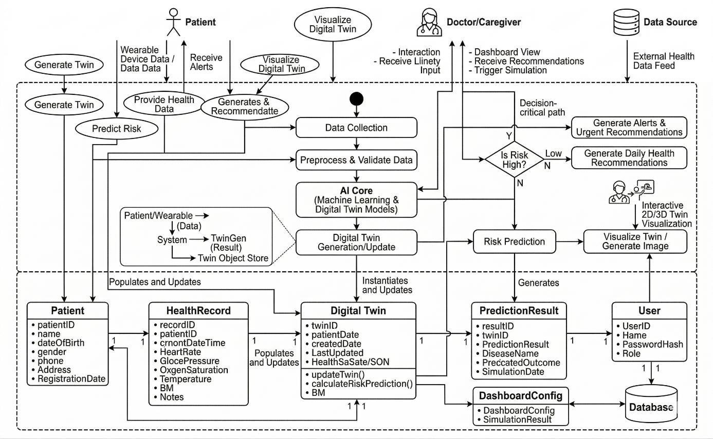

Fig 4.1 UML DIAGRAMS Workflow

The presented image shows a UML architectural diagram which depicts the operation of the AI-Driven Digital Twin Health Monitor System. The diagram displays three primary external actors who interact with the system. The patient provides wearable-device data and health data to the system and also receives alerts, while the doctor or caregiver interacts with the system by viewing dashboards, receiving recommendations, and triggering simulation or scenario analysis. The platform receives external health data from the data source which functions as a data provider to the system. The Data Collection process begins the workflow inside the main system boundary and then proceeds to Preprocess & Validate Data which takes incoming patient information and cleans it while checking its accuracy to prepare it for following steps. The AI Core receives the validated data which lets Machine Learning and Digital Twin Models work together to evaluate the patient's state. The AI core creates and updates Digital Twin which enables the system to make a virtual model of the patient that it updates with both current and past medical data.

    - USECASE DIAGRAM:
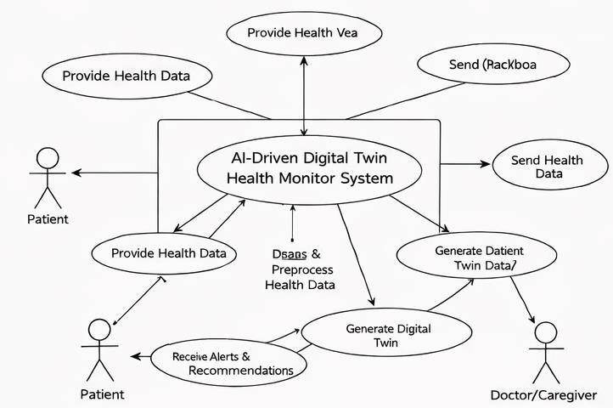

Fig 4.2 USECASE DIAGRAM Workflow

The Use Case Diagram shows all user-system interactions for the proposed AI-Driven Digital Twin Health Monitor System. The diagram's main component shows the system boundary which bears the name AI-Driven Digital Twin Health Monitor System. The healthcare platform serves as the core system which processes patient data to create digital twins and deliver healthcare insights to users. The diagram displays the Patient on its left and lower-left sections as a primary actor who uses the system to share his health information. The patient shares his health data through various sources which include his vital signs and wearable-device readings as well as his manual health records and routine physiological assessments. The patient uses the Receive Alerts & Recommendations use case because the system receives his data while providing him with health alerts and preventive recommendations and monitoring status updates.

CLASS DIAGRAM
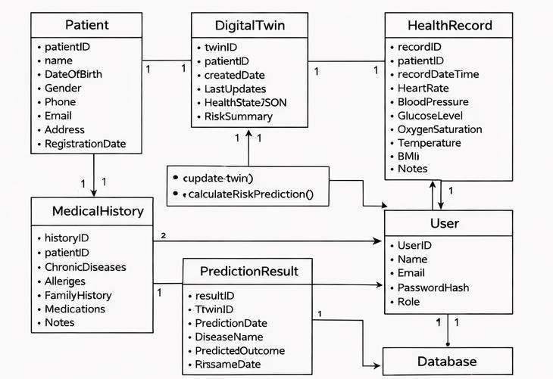

Fig 4.3 Class Diagram Workflow

The Class Diagram depicts the design of the AI-Driven Digital Twin Health Monitor System, which shows how the system's main software classes interact to store patient information and create digital twins and assess disease risk and control user access. The diagram starts with the Patient class, which functions as the main storage class for all personal and registration details that each patient has to provide, which includes their patientID, name, DateOfBirth, gender, phone, email, address, and registrationDate. The MedicalHistory class, which preserves permanent health information about patients, links to this class through its data fields, which include historyID, patientID, chronic diseases, allergies, family history, medications, and notes. The relationship demonstrates that every patient within the system possesses a medical history, which provides essential background information that supports digital health assessment processes.

DATAFLOW DIAGRAM

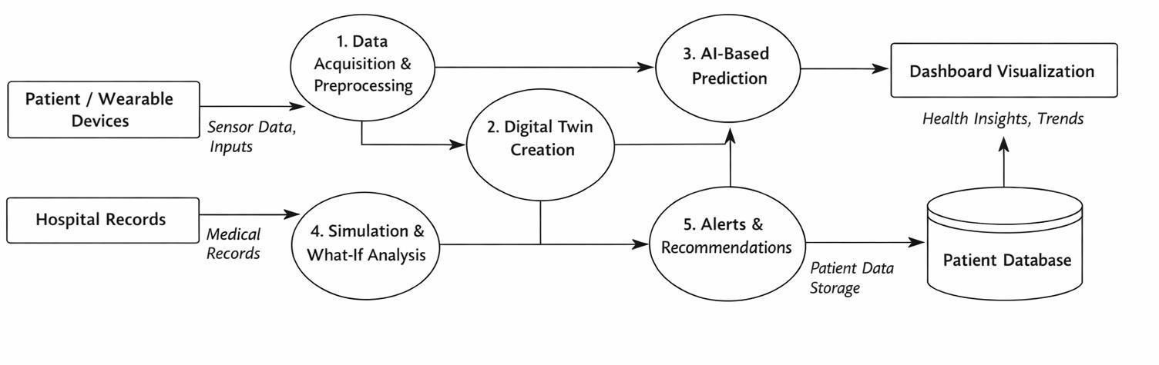

Fig 4.4 DATA FLOW DIAGRAM (DFD)

The proposed AI-Driven Digital Twin Health Monitor system DFD diagram shows the full data flow operation of the system throughout its health data processing stages. The system receives health data from two main input sources which are Patient / Wearable Devices and Hospital Records. The patient or wearable devices supply live or manual inputs such as heart rate, blood pressure, glucose level, oxygen saturation, body temperature, and other sensor- based measurements, while hospital records contribute historical and clinical data such as diagnosis reports, treatment history, laboratory values, and medical observations.

The Data Acquisition and Preprocessing module receives all inputs to collect raw data which undergoes a process of cleaning and validation and normalization before being transformed into a format suitable for analysis. The Digital Twin Creation module receives refined data which creates a dynamic virtual model of the patient by integrating current medical readings with historical health records. The digital twin serves as the main system model which shows the present medical state of the actual patient.
The digital twin data moves into the AI-Based Prediction module which uses machine learning and advanced analytics to identify potential disease risks and find unusual patterns and produce health predictions. The system includes a Simulation and What-If Analysis module, which analyzes potential future health scenarios through hospital records and processed patient data under different blood pressure and sugar level and other critical parameter changes.
The simulation and prediction results proceed to the Alerts and Recommendations module, which creates alerts and health recommendations and decision support tools based on the patient's current state. The Patient Database serves as the main storage system for processed outputs which include patient records and history tracking and prediction results and simulation results. The Dashboard Visualization component shows selected information from the database to doctors and caregivers and patients who want to see health insights through understandable presentation of trends and monitoring data.

ERD/STD
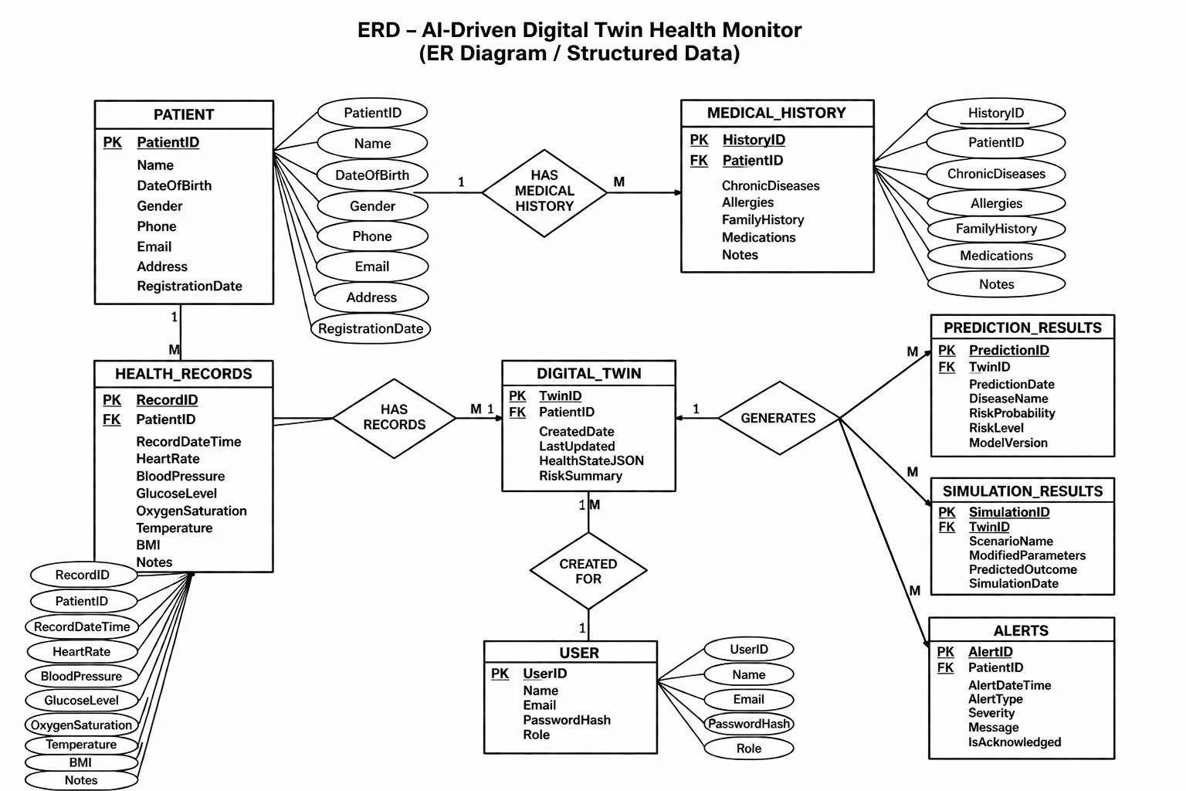
Fig 4.5 ERD/STD

The proposed AI-Driven Digital Twin Health Monitor system shows its Entity Relationship Diagram through this image, which describes its database structure that handles patient data and health documentation through organized methods of managing digital twin creation and prediction and simulation activities and emergency response situations. The PATIENT entity serves as the main table because it stores all essential patient information, which includes PatientID and Name and Date of Birth and Gender and Phone and Email and Address and Registration Date.
The system uses this entity structure because all medical records and monitoring documents need to link to specific patient information. The diagram shows that a patient can have multiple HEALTH_RECORDS, which means one patient may generate many health entries over time. The HEALTH_RECORDS entity stores timestamp-based physiological parameters such as Heart Rate, Blood Pressure, Glucose Level, Oxygen Saturation, Temperature, BMI, and Notes, which are collected from wearable devices, clinical observations, or manual inputs. The system uses multiple health records to create a permanent health record instead of keeping only records that exist at a particular time. The ERD shows that the patient has a relationship with MEDICAL_HISTORY, which stores data about Chronic Diseases and Allergies and Family History and Medications and Notes. This part is very important because the medical history gives long-term healthcare context that helps the system interpret present health conditions in a more personalized manner.
The DIGITAL_TWIN table serves as the main element in the diagram because it represents the most vital component of the proposed system. The table maintains the virtual patient model of the system through its TwinID, PatientID, CreatedDate, LastUpdated, HealthStateJSON, and RiskSummary fields. The system establishes a dynamic digital twin which shows the current and future health status of the patient after it gathers health records and patient background details.
The ERD shows that health records connect to the digital twin through the HAS RECORDS relationship because the twin construction process starts with the patient health records which update the twin throughout its existence. The digital twin functions as an advanced virtual healthcare system because it uses current data and historical information and health summaries to create a health model of the patient. The diagram displays the USER entity, which consists of UserID and Name and Email and PasswordHash and Role elements. The table enables user verification through authentication methods while establishing access permissions based on user roles which restrict system access to authorized personnel including doctors and administrators and patients.

The CREATED FOR relationship between USER and DIGITAL_TWIN establishes a link which connects the digital twin to a particular system user or patient identity, thus supporting ownership management and access control.
The right side of the ERD shows the process through which digital twin technology produces intelligent results. The GENERATES relationship connects DIGITAL_TWIN with PREDICTION_RESULTS and
SIMULATION_RESULTS and ALERTS, which serve as the three main output elements of the healthcare monitoring system in this research project.

The PREDICTION_RESULTS entity stores data such as PredictionID, TwinID, PredictionDate, DiseaseName, RiskProbability, RiskLevel, and ModelVersion, which means the system can apply machine learning models to the patient’s digital twin and then store disease-risk prediction results in a structured format. The system requires this information to track prediction results from the past and to measure risk changes throughout different periods.

The SIMULATION_RESULTS entity stores fields such as SimulationID, TwinID, ScenarioName, ModifiedParameters, PredictedOutcome, and SimulationDate, which represent the what-if analysis feature of the project. The system enables testing of future health outcomes through simulated patient parameter changes, which include increased blood pressure and better glucose control, and the system records these simulated results.

The ALERTS entity contains AlertID, PatientID, AlertDateTime, AlertType, Severity, Message, and IsAcknowledged, which shows that the system can generate health warnings and recommendations whenever a critical condition or abnormal trend is detected. The system enables early warning mechanisms and follow-up actions and clinical attention monitoring through its storage of alerts.
The ERD demonstrates that the AI-Driven Digital Twin Health Monitor system functions as a comprehensive data-based healthcare system because it uses a strong relational framework. The diagram shows how database design establishes connections between patient identification medical background health records digital twin representations artificial intelligence forecasts simulation results and alert systems.
The project requires more than just basic patient data recording because it needs to provide intelligent health analysis capabilities together with future forecasting functions and personalized monitoring systems through its established entity relationships. The system database design requires this ERD to provide clear scalable and maintainable storage solutions for both permanent patient data and real-time health monitoring data.
The system provides necessary functionalities for operating a digital twin healthcare platform by enabling users to update data in real time track historical information and access the system through secure methods. The system data organization backbone is shown in this image because it demonstrates how the internal database structure enables continuous predictive and customized healthcare monitoring.

ARCHITECTURE DIAGRAM
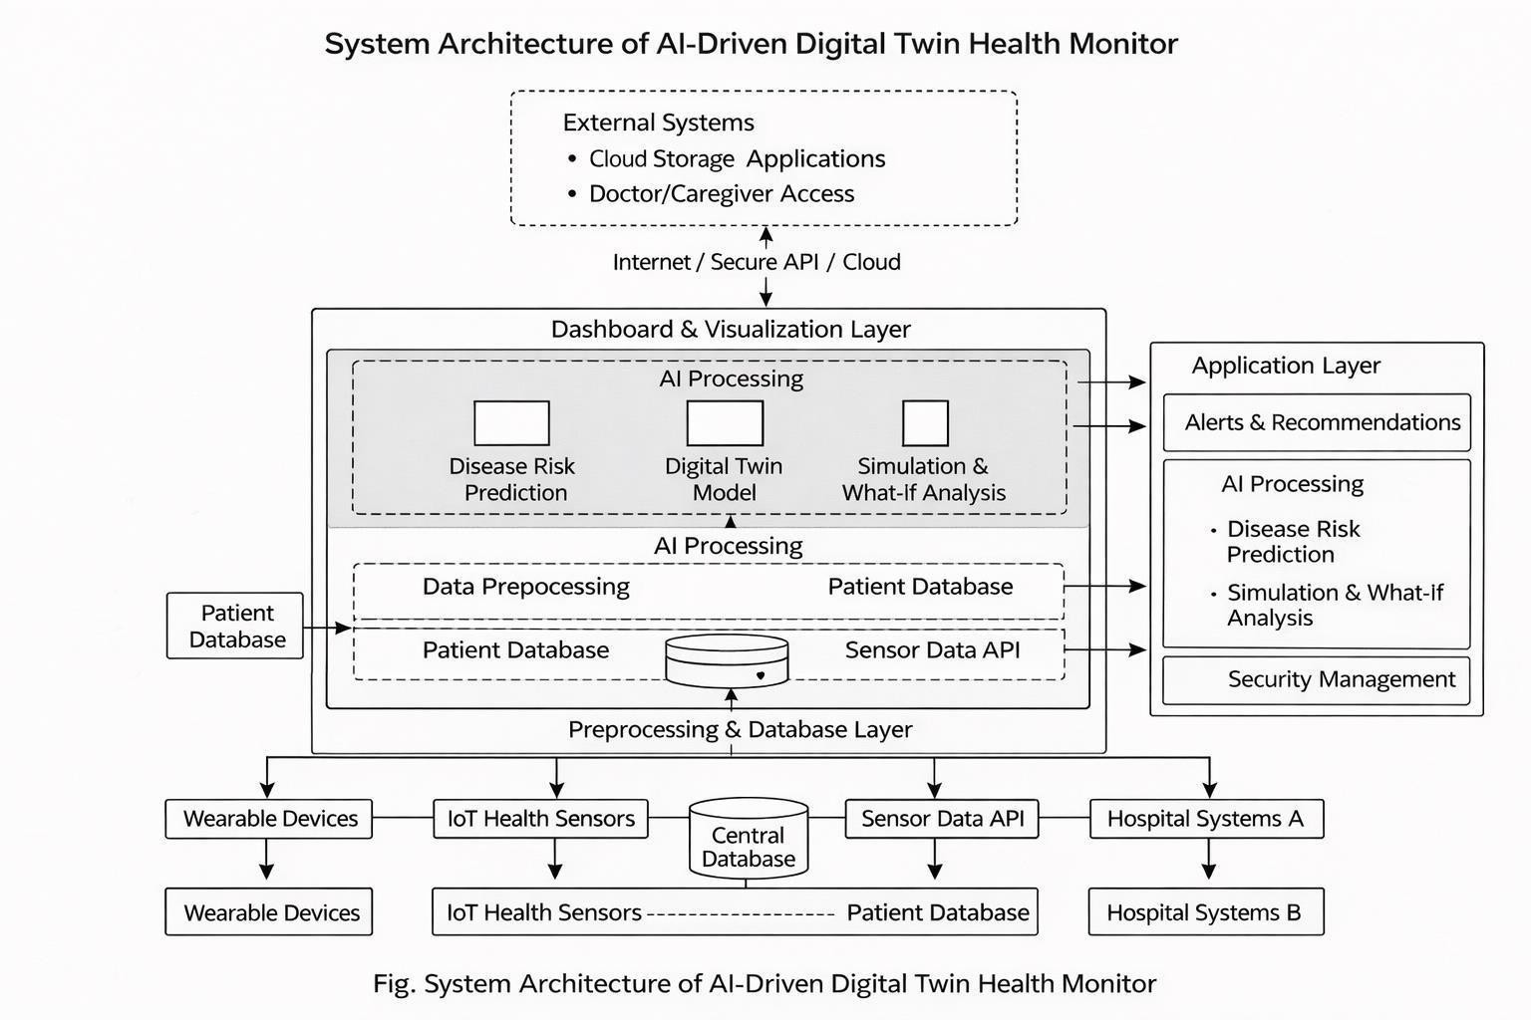

Fig 4.6 ARCHITECTURE DIAGRAM

The System Architecture of the AI-Driven Digital Twin Health Monitor is displayed through this image which uses a black-and-white format that avoids decorative icons to create a clean report style that meets academic document standards and project-paper display requirements. The architecture consists of multiple logical layers which demonstrate the process of health data transmission from its source systems to intelligent analysis and ultimate data visualization. The system receives lower-level inputs from Wearable Devices IoT Health Sensors Central Database Sensor Data API and Hospital Systems which together create the primary data collection environment used by the proposed healthcare platform. The system collects complete patient data through multiple channels because these sources deliver both real-time physiological measurements and
historical clinical records. The system processes incoming data through the Preprocessing & Database Layer which stores patient-related data and synchronizes it for upcoming analysis procedures. The Patient Database and Sensor Data API function as core storage and communication systems within this layer which enables structured access to health readings and medical records and streaming sensor data. The main system block contains the Dashboard & Visualization Layer which functions as the application core operational space. The first internal section of this layer focuses on AI Processing because it contains the major intelligent components which include Disease Risk Prediction Digital Twin Model and Simulation & What-If Analysis. The proposed system uses three essential modules to operate: machine learning methods, which the disease risk prediction unit uses to identify health threats, the digital twin model, which creates a virtual patient condition representation, and the simulation module, which investigates future outcomes by testing potential medical parameter modifications. The next internal section of the system again highlights AI Processing connected with Data Preprocessing and Patient Database, showing that before any advanced analysis is performed, the health data must be cleaned, validated, normalized, and transformed into a usable format. Another connected block inside the architecture displays Patient Database and Sensor Data API, which shows how patient history data and current device readings continuously exchange information. An Application Layer on the right side of the figure contains Alerts & Recommendations, which show detailed AI Processing functions that include disease-risk prediction and simulation-based what-if analysis and Security Management. The application layer transforms core system analysis results into actual healthcare services, which include user alerts and user recommendations and secure access for users.

CHAPTER 5
PROPOSED SYSTEM IMPLEMENTATION

CHAPTER 5
PROPOSED SYSTEM IMPLEMENTATION

HEALTH DATA ACQUISITION AND PREPROCESSING

The first module of the proposed system is the Health Data Acquisition and Preprocessing Module. It serves as the entry point for the entire AI-Driven Digital Twin Health Monitor. The main purpose of this module is to collect healthcare information about patients from various sources and convert that raw information into a clean, organized, and machine-readable format for further processing. In a digital healthcare environment, patient data can come from wearable devices, IoT health sensors, hospital databases, diagnostic equipment, mobile health applications, or manual entries provided by patients and doctors. This data may include factors such as heart rate, blood pressure, glucose level, oxygen saturation, body temperature, cholesterol level, BMI, ECG readings, age, gender, and lifestyle details. Since these inputs come from different sources, they may not always have the same format, completeness, or quality. Therefore, before creating the patient’s digital twin or using machine learning algorithms, the system must ensure that the incoming data is accurate, complete, and standardized.
This module starts with data acquisition, where health values are collected and temporarily stored in the system. At this stage, each incoming record is connected with the corresponding patient identity, ensuring that health measurements are accurately associated with the right person. Once the records are collected, the system performs data validation. This validation checks for missing values, duplicate entries, invalid characters, medically impossible values, and inconsistent data types. For instance, if blood pressure is recorded incorrectly or a glucose value is missing, the system identifies these issues and either corrects them using predefined rules or flags them for further review. This enhances data

reliability and make sure that the digital twin is not created using faulty measurements.
After validation, the preprocessing stage carries out several important tasks. Dealing with missing values may involve deletion, mean substitution, interpolation, or carrying forward previous values, depending on the data type and frequency. Duplicate records are removed to prevent repeated influence on model learning. Numerical health attributes are normalized or standardized to ensure that different feature scales do not negatively impact machine learning performance. Categorical values such as gender, risk class, and medical history flags are converted into numerical form so they can be processed by the AI model. Temporal data, like repeated measurements over time, is organized chronologically to aid trend analysis. Handling outliers is also crucial in this module because extreme values may indicate device noise, recording errors, or emergency conditions. Thus, the system may smooth the values, flag them, or keep them based on clinical interpretation rules.
This module is essential because the entire system's quality depends on the quality of the input data. Even the best digital twin or AI model cannot produce meaningful predictions if the data is inaccurate or poorly structured. Therefore, the Health Data Acquisition and Preprocessing Module forms the technical foundation of the proposed healthcare monitoring system. It ensures that only validated and properly formatted patient information is passed to the next modules, thus improving system performance, prediction reliability, and overall healthcare decision support.

Algorithm : Health Data Acquisition and Preprocessing Algorithm 5.1: Health Data Acquisition and Preprocessing
Input: Raw patient health data from wearable devices, hospital systems, sensors, or manual input

Output: Cleaned, validated, and preprocessed health dataset Start
Receive patient health input from one or more data sources Identify patient using Patient ID or registered profile Store raw input temporarily in acquisition buffer
Check whether all required fields are present
If fields are missing, apply missing value handling or mark for review Check for duplicate records using timestamp and patient ID
Remove duplicate records if found

Validate numerical ranges of health parameters Detect inconsistent or invalid values Normalize or standardize numerical data
Encode categorical attributes into machine-readable form Arrange records in chronological order
Store cleaned data in patient database

Forward preprocessed data to Digital Twin Creation Module Stop

Explanation of Algorithm 5.1
This algorithm starts by receiving raw patient health records from the connected input sources. Once the input is obtained, the system links the record to the right patient identity. The data is then checked for missing values and duplicate records. Next, the algorithm validates whether health parameters fall within acceptable ranges. If the data is acceptable, numerical features are normalized,

and categorical values are encoded. The final output is a refined patient dataset that is ready for constructing the digital twin and for intelligent analysis. This algorithm improves data consistency, removes noise, and ensures that later predictions are based on reliable information.

Implementation Steps of Module 1
The practical implementation of Module 1 can be done step by step. First, the user interface or API receives health data from sensors, hospital records, or manual forms. Second, the backend processes the values and stores them in a raw- data table. Third, validation functions check for null values, format mismatches, and impossible measurements. Fourth, preprocessing functions clean and convert the data into a format suitable for features. Fifth, the final processed data is stored in the central patient database and sent to the digital twin engine. In terms of implementation, Python libraries like Pandas and NumPy can be used for preprocessing, while Flask or Fast API can manage data transfer between the frontend, backend, and storage.
Advantages of Module 1
This module enhances the overall system by ensuring input quality, reducing noise, supporting multiple data sources, and making the dataset suitable for machine learning. It also supports scaling, allowing the acquisition pipeline to extend as new sensors or devices are introduced. Most importantly, this module provides the reliable health data foundation necessary for the patient digital twin and risk prediction system.

DIGITAL TWIN CREATION AND AI-BASED DISEASE PREDICTION
The second major part of the proposed system is the Digital Twin Creation and AI-Based Disease Prediction Module. This serves as the smart core of the AI- Driven Digital Twin Health Monitor. After collecting and processing patient data,

this module uses that information to create a virtual representation of the patient, known as the digital twin. The digital twin is not just a stored health record; it is a dynamic model that reflects the patient's health condition in real-time, using current readings, past data, and interpreted risk indicators. It acts as a living digital copy of the patient and serves as the main basis for prediction, monitoring, and simulation.
The process starts with creating the digital twin, where validated health parameters are turned into a structured patient-state model. This model may include current physiological values, indicators based on history, markers for chronic diseases, summaries of medical history, and trend information. For instance, a patient’s digital twin may show not only the latest blood pressure and glucose levels, but also whether these values are increasing over time, how they compare to earlier readings, and whether the patient is part of a high-risk clinical group. This makes the digital twin more valuable than a simple health database, as it organizes the data into a condition-aware format that supports smarter healthcare reasoning.
Once the digital twin is created or updated, the module sends the patient-state features to the AI-based disease prediction engine. At this point, machine learning algorithms analyze the patient’s digital twin and estimate the likelihood of various health risks. Depending on the project’s design, the AI engine may predict conditions like heart disease, diabetes, hypertension, stroke, or general health decline. The prediction engine may use algorithms such as Logistic Regression, Random Forest, Decision Tree, Support Vector Machine, XGBoost, or Neural Networks. These models assess the connection between health features and disease outcomes, generating a risk score or probability. Based on this probability, the system categorizes the patient as low risk, medium risk, or high risk.

A significant strength of this module is its ability to enable personalized predictive healthcare. Instead of relying solely on threshold-based alerts, the system learns from individual combinations of health parameters and provides smarter, data-driven insights. For example, slightly high blood pressure may mean different things for different patients; the AI engine interprets it in relation to age, BMI, glucose levels, previous readings, and overall medical history. This makes the output more personalized and useful for preventive care. By continually updating the digital twin and running prediction models on the latest health data, this module helps identify disease risk early, facilitates timely interventions, and supports better medical decision-making.
Algorithm for Digital Twin Creation and AI-Based Prediction Algorithm 5.2: Digital Twin Creation and AI-Based Disease Prediction Input: Preprocessed patient health data
Output: Updated digital twin and disease-risk prediction result Start
Receive cleaned patient dataset from Module 1 Retrieve patient profile and historical medical records Combine current values with historical records Generate or update patient digital twin
Extract relevant features from digital twin Load trained machine learning model Send feature vector to prediction model Compute disease-risk probability
Classify prediction output into risk category

Store updated digital twin in Digital Twin table Store prediction result in Prediction Results table Send risk output to dashboard and alert module Stop

Explanation of Algorithm 5.2
This algorithm takes the preprocessed patient data and merges it with the individual's historical health information. Using this combined view, it updates the digital twin and extracts a feature vector for AI analysis. The trained model then processes the features and estimates the probability of a selected disease condition. The output is stored in the system database and sent to the dashboard for display. This algorithm is important because it turns static health values into intelligent prediction results and keeps track of the patient’s state continuously.

Implementation Steps of Module 2
The implementation starts by reading the patient’s processed data and profile history from the central database. Then, a digital twin object is created or updated. This object may be stored in JSON form, structured fields, or a feature table. After this, the system extracts the necessary parameters needed by the machine learning model. A pre-trained classification model is then loaded from storage. The model assesses the feature vector and returns a disease-risk score. The system saves the result while also updating the dashboard, alerts, and simulation modules. Libraries like Scikit-learn, TensorFlow, or PyTorch can be used for the AI engine, while MySQL or PostgreSQL can store digital twin and prediction results.

Advantages of Module 2
This module provides the most significant contribution of the proposed system. It creates a virtual representation of the patient, supports continuous updates of health states, offers intelligent disease-risk predictions, enables personalized

healthcare analysis, and enhances preventive healthcare efforts. It also allows for future integration with explainable AI and simulation modules.

5.3 MODULES OF THE PROPOSED SYSTEM
The proposed system is divided into several modules, each designed to handle a specific part of the healthcare monitoring pipeline. These modules work together to create an end-to-end digital twin healthcare solution.

Secure Health Data Acquisition Module
This module is responsible for collecting patient-related information from different sources and bringing it into the system in a secure and structured form. The data collected may include heartrate, blood pressure, body temperature, oxygen saturation, glucose level, cholesterol level, ECG data, respiratory rate, BMI, age, gender, medical history, medication details, physical activity, sleep pattern, and lifestyle behaviors such as smoking or alcohol consumption. The acquisition process may take place through manual entry, hospital database retrieval, wearable device synchronization, mobile app submission, or API-based sensor integration.
The system has a special part that checks the data coming in to make sure it's real, complete, and can be used. This is important because healthcare data can come from many different places, so the system needs to be able to handle different types of data without getting confused. Also, only people and devices that are allowed should be able to add data to the system. To make sure of this, the system checks who the users are, makes sure the devices are okay, and uses safe ways of communicating. This first part of the system is crucial because the accuracy of the predictions and simulations that come later depend on the quality of the data that's put in. If the data is bad, the predictions and simulations will be too. So, it's essential to get this part right to ensure that the whole system works well.

Data Preprocessing and Validation Module

After raw health data is collected, it passes to the preprocessing and validation module. This module cleans the data and prepares it for digital twin creation and AI analysis. In real healthcare environments, raw data may contain missing values, duplicate entries, abnormal ranges, inconsistent units, or typographical errors. If such data is used directly, the reliability of the prediction model and digital twin would be affected.
The preprocessing stage performs operations such as null-value handling, duplicate removal, outlier checking, noise filtering, normalization, standardization, encoding of categorical values, and unit conversion. For
example, blood pressure may need to be represented in a standard numerical format, glucose values may require normalization, and lifestyle fields may need categorical encoding. The module also validates whether the input values fall within medically acceptable and system-acceptable ranges. Records that fail validation can be flagged, rejected, or sent for manual review.
This part of the system makes sure the patient's digital copy is accurate and reliable. It also helps the computer programs that learn and make predictions work better, because when the data is correct and organized, the results are more useful and trustworthy.

Patient Profile Management Module

The patient profile management part of the system is like a big file that keeps all the important information about each patient. It's the main part that helps the system work properly. This part stores things like the patient's name, age, and address, as well as their medical history, any long-term health problems they have, and what they've been diagnosed with in the past. It also keeps track of their family's medical history, any allergies they have, and their lifestyle habits. And, it stores information about the treatments they've had. Each patient gets their own special profile, so all their health records, test results, and other important information are connected to the right person. This way, doctors and nurses can easily find the information they need to take care of their patients.
This module is crucial because a digital twin should not be treated as a general- purpose model. It should reflect the uniqueness of a specific person. Therefore, patient-specific context must be stored and continuously updated. The system may also use this profile information to personalize prediction thresholds, interpret outputs more accurately, and generate more relevant suggestions.
The patient profile management module also supports role-based access. For example, patients may view their own dashboard, while doctors may have expanded access to clinical details and trend reports. Caregivers may receive alerts based on permission. Thus, this module not only organizes patient identity but also connects the system to practical healthcare workflows.

Digital Twin Modeling Module
The core of our system is the digital twin modeling module. It's what creates and updates a virtual copy of the patient, using the latest health data and information about their past. This virtual copy is not just a collection of data - it's a complex model that shows the patient's current health, how it's changed over time, and what risks they might face in the future. The digital twin is a dynamic tool that helps us understand the patient's situation and make informed decisions about their care. By using this model, we can get a better sense of what's going on with the patient and what might happen next, which can be really helpful in providing the best possible treatment.
Whenever new physiological or clinical data is received, this module updates the corresponding digital twin. It may maintain a temporal view of the patient’s condition, such as changes in blood pressure over time, repeated variations in glucose levels, or gradual increases in body weight and cholesterol. This helps the system understand patient health as a continuous process rather than a series of unrelated records.The digital twin may be represented internally as a feature vector, object model, or linked health state structure. The design may include sections for real-time signals, chronic condition flags, trend indicators, and risk markers. The module must also synchronize past and current information in a meaningful way, ensuring that the digital twin remains accurate, traceable, and suitable for downstream prediction and simulation tasks.

AI-Based Disease Prediction Module

The AI-based disease prediction module applies machine learning techniques to the patient digital twin in order to estimate disease risk, detect abnormal health behavior, and support early warning generation. This module transforms the system from a monitoring platform into an intelligent healthcare assistant. Based on the patient’s current and historical health attributes, the AI engine predicts the probability of conditions such as diabetes, hypertension, cardiovascular disease, stroke, or generalized health deterioration.
The machine learning models used in this module may include Logistic Regression, Random Forest, Decision Tree, Support Vector Machine, XGBoost, Neural Networks, LSTM for time-series patterns, or ensemble methods. The choice of model depends on the dataset, feature structure, interpretability needs, and computational complexity. During training, the model learns patterns that distinguish low-risk from high-risk health states. During prediction, it uses the latest digital twin data to generate risk scores and classification outcomes.
This module is designed to be extensible. New disease prediction models can be added in the future. The system may also support multi-output prediction, where several disease risks are computed simultaneously. The AI module should not be viewed as a substitute for medical diagnosis, but as a decision-support mechanism that can provide early indications and guide timely healthcare response.

Simulation and What-If Analysis Module
One of the most innovative components of the proposed system is the simulation and what-if analysis module. While traditional monitoring systems stop at current-state observation, this module attempts to forecast how the patient’s future condition may change under modified circumstances. It enables the user to explore scenarios such as: What happens if glucose level decreases? How will risk change if blood pressure is controlled? What if cholesterol rises further? How does physical inactivity affect long-term cardiac risk?
To perform this task, the module accepts the patient’s existing digital twin as a baseline and then modifies one or more variables according to a hypothetical scenario. The modified twin is then passed through the prediction engine to estimate future risk changes. This creates a scenario-based comparison between the present condition and the simulated condition. In some implementations, Monte Carlo simulation, probabilistic perturbation, or repeated feature variation may be used to study uncertainty and sensitivity.
This tool is really useful for planning healthcare ahead of time. It helps doctors talk to patients about how treatments might affect them, and it helps patients see how changing their lifestyle could impact their health. So, it's like turning data into a way to predict what might happen, which is really powerful.

Alert Generation and Recommendation Module
The alert generation and recommendation module converts prediction results and abnormal trends into actionable feedback. When the system detects a high-risk pattern, sudden physiological abnormality, or deteriorating trend, it generates an alert. Alerts may be categorized as low, medium, or high severity depending on the risk level and urgency. For example, persistent hypertension trend, high

diabetes risk, or rapidly decreasing oxygen saturation may trigger different alert mechanisms.
In addition to alerts, the module generates basic recommendations. These recommendations may include advice such as follow-up consultation, periodic testing, medication adherence reminder, hydration warning, activity encouragement, or dietary monitoring suggestion. In an academic prototype, such suggestions are usually general and supportive rather than clinical prescriptions. Their purpose is to enhance awareness and encourage timely action.
This module improves the usefulness of the system because prediction results alone may not be enough for users. By translating risk into understandable warnings and recommendations, the system becomes more practical and user- centered.

Dashboard and Visualization Module
The dashboard and visualization part of the system is what users see and interact with. It shows how healthy someone is, warns about potential risks, and gives results from simulations, all in a way that's easy to understand and interact with. Because medical information can be really complicated, visualization helps turn complicated data into something that makes sense. This is important because it lets people easily see things like trends and warnings, which can help them make better decisions about their health. The system uses graphs and other visual tools to make the information clear and simple to use.
The dashboard may contain sections such as patient summary, current vital parameters, disease-risk scores, historical trend charts, alert notifications, simulation controls, and recommendation cards. Graphs may be used to show glucose trends, blood pressure variation, heart rate distribution, and predicted risk over time. Gauges or colored indicators may be used to represent current risk

severity. A simulation panel may allow doctors or users to adjust selected variables and immediately view the predicted outcome.This module improves communication between healthcare professionals and patients. It also supports remote monitoring, since a patient’s data and trends can be viewed from another location. A good dashboard design increases usability, confidence, and adoption of the system.

Database and Storage Module

The database and storage module handles all persistent data required for system operation. This includes patient registration details, health records, device data, prediction outputs, simulation results, alerts, audit logs, and access metadata. Since the project deals with multiple categories of healthcare information, the database design must be organized and relationally structured.
A typical database may include tables such as:

Patient Master Table Health Parameters Table Medical History Table Prediction Results Table Simulation Logs Table Alert Logs Table
User Credentials Table Device Integration Table
The database must support efficient retrieval of patient history and trend data because the digital twin depends on temporal continuity. Proper indexing, backup
mechanisms, and secure storage practices are also necessary. This module ensures the long-term reliability and maintainability of the proposed system.

SYSTEM WORKFLOW
The workflow of the proposed system follows a logical sequence from data input to intelligent health output.
First, the patient or device submits health data into the system. The input may come from wearable sensors, clinical records, or manual entry. Second, the system validates the incoming data and performs preprocessing operations to remove noise and standardize values. Third, the patient profile is identified and the corresponding digital twin is updated with the new information. Fourth, the AI prediction engine analyzes the updated twin and generates disease-risk scores, abnormality detection results, and health insights. Fifth, the simulation engine may be invoked to test hypothetical future conditions. Sixth, the alert and recommendation module interprets the output and generates appropriate guidance. Finally, the dashboard displays all results in a user-friendly form.
This process makes sure that things keep moving smoothly. As more information about the patient becomes available, the computer model of the patient gets better and better, giving a more accurate picture of their health. The more data that is added, the more the system learns about the patient's health over time, which helps make better predictions and more helpful simulations.
DATA FLOW DESIGN
The data flow design of the proposed system shows how information moves from source to output. The flow can be described in the following sequence:

Input Sources -> Validation -> Preprocessing -> Patient Profile Mapping -> Digital Twin Update -> AI Prediction -> Simulation -> Alerts/Recommendations
-> Dashboard Output -> Secure Storage
At the input stage, raw data enters the system. During validation, the format and consistency of the data are checked. Preprocessing converts raw values into usable features. Profile mapping ensures that the data belongs to the correct patient. The digital twin update stage synchronizes new information with existing patient state. The AI engine then produces risk prediction and anomaly analysis. The simulation engine explores future scenarios. The recommendation engine interprets outputs into messages. The dashboard displays results. All processed information is then stored securely for history, analysis, and future updates.
This data flow design is important because it ensures that the system is organized, traceable, and logically structured. It also helps in software implementation and documentation.

FUNCTIONAL DESIGN
The functional design describes what the system should do from the user and process perspective. The major functions of the proposed system are as follows:
Register and manage patient profiles Acquire health data from multiple sources Validate and preprocess incoming data Create and update digital twin models Predict disease risk using AI models Perform simulation-based what-if analysis Generate alerts and recommendations

Display health trends and risk results Store patient history and analysis logs
Support secure access and user authentication
Each function contributes to the larger goal of intelligent healthcare monitoring. The design ensures that the system is not limited to raw data storage, but can transform patient data into decision-support information.

NON-FUNCTIONAL DESIGN
Apart from functional behavior, the proposed system must also satisfy several non-functional requirements.
Security: Patient data must be protected during collection, storage, and access. Authentication, authorization, encryption, and audit logging are important.
Scalability: The system should support multiple patients and increasing data volume without major redesign.
Reliability: Predictions and dashboard outputs should remain stable and available even when new data arrives frequently.
Usability: The interface should be simple enough for patients while still useful for healthcare professionals.
Because the system is made up of separate parts, it's easy to update or fix one part without affecting the rest. This makes it simpler to keep the system running smoothly and make changes as needed.
Interoperability: The system should be capable of future integration with wearable devices, mobile apps, hospital systems, and cloud services.

Performance: The time taken to process data, update the twin, and display results should remain within acceptable limits.
These non-functional qualities ensure that the proposed design is practical and sustainable.

FEATURE DESIGN FOR THE DIGITAL TWIN
The quality of the digital twin depends on the features chosen to represent the patient. Therefore, the proposed system includes a carefully designed feature structure. These features may be divided into the following categories: Demographic Features: age, gender, height, weight, BMI
Vital Features: heart rate, blood pressure, temperature, respiratory rate, oxygen saturation
Biochemical Features: glucose, cholesterol, HbA1c, lipid profile Cardiac Features: ECG values, pulse variability
Behavioral Features: physical activity, sleep duration, smoking, alcohol intake
Medical History Features: previous diagnosis, family history, medication usage, chronic condition flags
Temporal Features: weekly averages, trend slopes, repeated abnormal event count Risk Features: prior AI score, risk class, recent alert severity
These features allow the digital twin to represent the patient in a multidimensional way. The richer the feature set, the more useful the system becomes for analysis and simulation.

LOGICAL DESIGN OF THE DATABASE
The logical database design supports the overall architecture of the proposed system. A simplified relational structure may include:
Patient Table

Stores patient ID, name, age, gender, contact, registration date. Medical_History Table
Stores patient ID, chronic diseases, allergies, family history, medications. Health_Records Table
Stores timestamped measurements such as heart rate, BP, glucose, oxygen saturation, BMI.
Digital_Twin_State Table
Stores computed health-state representation, feature vector summary, trend markers.
Prediction_Table
Stores predicted disease name, probability score, prediction date, model version. Simulation_Table
Stores scenario name, modified parameter, baseline score, simulated score, result date.
Alert_Table

Stores alert type, severity, message, generated time, acknowledged status. User_Table
Stores login credentials, role type, account status.

This logical design ensures that structured storage supports continuous monitoring and historical analysis.

ALGORITHMIC DESIGN
The algorithmic design of the system can be explained in the following steps: Algorithm for Digital Twin Update
Receive new patient data Validate and preprocess input Retrieve existing patient profile
Merge new values with old records Update trend features and current state Save new digital twin representation Algorithm for Disease Prediction
Extract current feature vector from digital twin Select relevant trained model
Apply model to feature vector Generate probability score
Classify risk as low, moderate, or high Store result and send to dashboard Algorithm for Simulation
Load baseline digital twin
Accept hypothetical input changes

Generate modified feature vector

Run prediction engine on modified state Compare simulated score with baseline score Display change in risk and interpretation
These algorithms demonstrate that the proposed system is not a one-step tool, but a continuous intelligence pipeline.

SECURITY AND PRIVACY DESIGN
When it comes to handling health data, keeping it safe and private is crucial. So, the system we're designing has to have strong security and privacy features. To start with, we're including a user authentication process, which means only people who are registered and allowed to use the system can actually get in and see the records. We're also using something called role-based access control, which means different types of users can only see the data that's relevant to them. For instance, patients can look at their own health monitoring data, but doctors can see more detailed clinical information that helps them make better decisions. This way, we can make sure that sensitive health information doesn't fall into the wrong hands.
Data encryption may be used during communication and storage. Sensitive details such as login credentials and confidential identifiers should be stored securely. Audit logging helps maintain a record of who accessed or modified which information. Backup and recovery planning may also be included to prevent data loss.
The system is designed to support trust. In healthcare applications, trust is as important as technical accuracy. Therefore, privacy-preserving design is a key strength of the proposed model.

RESULTS FOR THE PROPOSED MODEL WITH GRAPHS
The results of the proposed AI-Driven Digital Twin Health Monitor show that the system can collect patient data, preprocess it, create a digital twin, predict health risks, and present the findings in a meaningful way through visual outputs. In this model, results are produced at multiple levels. The first level relates to the accuracy of data acquisition and preprocessing, where raw patient values are successfully validated and converted into a structured dataset. The second level involves digital twin creation, where a virtual representation of the patient is developed using the processed data. The third level focuses on AI-based disease- risk prediction, where the trained machine learning model analyzes the digital twin and generates a disease probability or risk classification. The last level is the visualization stage, where outputs are displayed through graphs, trend plots, and dashboards for easier interpretation.
In this model, results can be discussed in terms of patient monitoring accuracy, quality of disease-risk classification, temporal health tracking, and simulation usefulness. When patient data is entered into the system, the preprocessing module removes inconsistencies and improves feature quality. This leads to better prediction performance because the machine learning model receives cleaner input. The digital twin keeps the patient's history and current status together, allowing the system to understand the patient condition more effectively than traditional record-based systems. The prediction engine can then produce a clear risk level, such as low, moderate, or high, based on the patient’s health profile. This output is used by the dashboard and alert system to inform healthcare users.

The results section also includes visual graphs, since graphical representation is crucial in healthcare monitoring. A graph showing risk probability comparison can display how the model classifies multiple patients or how one patient’s risk changes over time. Another graph showing health parameter trends can illustrate changes in glucose levels, blood pressure, or oxygen saturation over repeated time intervals. A simulation graph can demonstrate how changing a specific parameter affects the predicted disease risk. These graphs enhance understanding and support the digital twin concept.
Result Analysis Areas

You can divide your results into three parts:
- Data Preprocessing Result

This result shows how missing values, duplicates, and invalid entries were managed before creating the digital twin.
- Prediction Result
This result shows how the machine learning model produced risk scores and risk categories from the patient digital twin.
- Visualization and Simulation Result

This result shows how graphs and dashboard outputs clearly presented health conditions and future what-if analysis.

Graph 1: Disease Risk Prediction Graph

Title: Disease Risk Probability for Sample Patients This graph can be shown as a bar chart.
On the X-axis, place patient IDs or patient groups. On the Y-axis, place disease-risk probability values.

Example interpretation:
The graph indicates that Patient 1 has a low disease-risk probability, Patient 2 has moderate risk, and Patient 3 has high risk. This illustrates that the AI model can classify different patient conditions based on the digital twin features. The graph also helps doctors quickly identify high-risk patients needing immediate attention.

Graph 2: Health Parameter Trend Graph
Title: Variation of Blood Pressure / Glucose Level Over Time This graph can be shown as a line graph.
On the X-axis, place time intervals such as day, week, or month. On the Y-axis, place the selected health parameter values.

Example interpretation:
The trend graph shows how the patient’s blood pressure or glucose level varies over time. If the graph reflects a continuous upward trend, it indicates a worsening health condition. If the graph gradually declines after intervention, it suggests improvement. This graph supports ongoing monitoring and illustrates the usefulness of the digital twin for tracking health over time.

Graph 3: Simulation and What-If Analysis Graph
Title: Comparison Between Current Risk and Simulated Future Risk This graph can be shown as a comparison bar chart or dual-line graph.
On the X-axis, place health scenarios such as current condition, improved glucose levels, reduced blood pressure, increased BMI, and high cholesterol.
On the Y-axis, place predicted disease-risk probability.

Example interpretation:
This graph shows that as health parameters improve, the predicted disease risk decreases, while worsening parameters lead to an increase in predicted risk. This demonstrates that the simulation module can provide valuable future-state analysis and helps doctors or patients understand the effects of medical and lifestyle changes.

Discussion of Results
The proposed model shows that combining data preprocessing, digital twin modeling, and machine learning lays a solid foundation for predictive healthcare monitoring. The system does not just store patient data; it turns it into intelligent, patient-specific insights. The graphs clearly demonstrate that the model can track health changes over time, classify disease risk, and simulate future conditions. This makes the system suitable for chronic disease management, telemedicine, home healthcare, and preventive medical support. While the results may initially rely on prototype or sample datasets, they still highlight the practical value of the proposed framework.
The results also suggest that the digital twin concept enhances healthcare interpretation by organizing the patient’s current state, past state, and expected future state into one cohesive model. The disease prediction graph aids in early identification of high-risk cases. The trend graph supports long-term monitoring. The simulation graph assists decision-making by illustrating how medical or lifestyle changes may influence future outcomes. Together, these results confirm that the proposed system is not only technically functional but also valuable from a healthcare management standpoint.

CHAPTER 6 TESTING AND VALIDATION

CHAPTER 7 TESTING AND VALIDATION

INTRODUCTION

Testing and validation are crucial elements which determine whether the AI-Driven Digital Twin Health Monitor system functions as intended while generating healthcare results which meet the requirements for patient monitoring and digital twin development and disease risk evaluation and simulation analysis. The project necessitates component evaluation because its design includes data acquisition and preprocessing and database storage and digital twin modeling and artificial intelligence and alerts and dashboard visualization. A healthcare-oriented system cannot be considered useful unless its input handling is reliable, its processing is accurate, and its final outputs are understandable and consistent. The testing and validation phase determines whether the system operates as required under various testing conditions.

The proposed model tests software performance through two methods which include error detection and additional testing procedures. The testing process verifies six different aspects which include checking patient data acceptance and testing methods for dealing with missing or invalid records and monitoring digital twin updates and validating structured disease-risk output generation and assessing simulation engine behavior through health parameter modifications. The validation process establishes whether results produced by the system hold value for healthcare monitoring purposes. The system should display increased health risk when blood pressure and glucose levels rise above normal patient values. The system produces intelligent results because it generates output which makes sense instead of delivering unpredictable output.

OBJECTIVES OF TESTING
The primary testing purpose for the proposed system tests all module functions because they need to demonstrate proper operation and inter-system coordination. The first objective is to ask the system to receive patient data from multiple sources while accurately storing this information in the database. The second objective requires the system to detect and process all invalid, incomplete, and duplicate values during the preprocessing stage. The third objective requires confirmation of proper digital twin creation for the patient which needs to update whenever new health records enter the system. The fourth objective tests whether the AI-based disease prediction model generates organized and meaningful results from the processed health information.

The main purpose of this research project is to validate the accurate functioning of the simulation system through multiple what-if analysis tests. The project includes this feature as a core innovative element, so it requires testing whether selected patient parameters create changes to risk prediction results. The next objective requires the system to create alerts and recommendations which should activate during detection of abnormal or high- risk situations. The dashboard needs testing to confirm correct display of graphs and health summaries and alerts and patient trend information.
The testing process exists to verify three system qualities which include system stability and system usability and system consistency. A healthcare monitoring system should operate continuously without interruption when users submit identical data multiple times and staff members update different records for the same patient. The system needs to operate correctly because it must track patients accurately while storing their medical history and maintaining dependable performance throughout its operational life. The testing objectives require two types of assessment which include technical evaluation and functional evaluation to determine how well the system performs its tasks.

TYPES OF TESTING USED

The proposed AI-Driven Digital Twin Health Monitor undergoes multiple testing methods for its evaluation. The testing process includes unit testing and integration testing and system testing and functional testing and validation testing and performance testing and user-level testing. The project achieves proper quality control through the implementation of different testing categories which create distinct functions.

Unit testing examines single components through testing methods which include data validation functions and preprocessing routines and patient-record insertion logic and risk-calculation functions and alert-generation routines. The process of testing each module in isolation helps to establish its proper function before connecting it to the whole system. The process of integration testing establishes that different software modules interact through proper communication channels. The system requires proper data transfer from preprocessed data to the digital twin module which needs to establish a direct connection with the AI model that produces output for the dashboard and alerts module.

System testing evaluates the complete functionality of the system. The entire health-monitoring system undergoes testing in this phase which checks all aspects from its initial input until its final output. The system functional testing verifies whether the system dedicates its resources to executing all required operations including patient registration and record insertion and digital twin updates and prediction display and simulation analysis and dashboard creation. The testing process evaluates whether the output results make sense and follow established healthcare principles.

TESTING ENVIRONMENT
The development team conducts testing of their system within a specialized development environment which meets the requirements for handling healthcare data and conducting machine learning operations and displaying results through web-based interfaces. The software environment requires Python to create models and logical processes while Pandas and NumPy handle data preprocessing tasks and Scikit-learn or matching frameworks perform disease-risk prediction. The testing process requires execution on a standard workstation which has enough RAM and processor power to handle multiple data entries and model runs and graph displays.
The system conducts testing by populating the database with sample patient records which represent various health conditions to test the system across multiple risk categories from low to moderate to high. The testing environment also includes time-based repeated records to verify whether the digital twin updates properly and whether trends are correctly reflected. The dashboard is checked using different input cases, including normal values, abnormal values, and simulated modified scenarios. The system undergoes evaluation through controlled testing which creates a systematic testing environment that allows tests to be repeated.

The testing environment matters because it recreates actual healthcare monitoring systems without needing complete medical testing. The system enables safe testing of the proposed model through its testing environment which allows users to see the model's operation and make necessary adjustments before testing in real-world situations.

TEST CASES & REPORTS

TEST  CASE ID | TESTCASE/  ACTION TO PERFORMED | EXPECTED RESULT | ACTUAL RESULT | PASS/ FAIL
TC_01 | Enter valid patient profile | Patient should be registered successfully | Patient profile stored correctly | Pass
TC_02 | Enter incomplete health record | System should reject or flag missing fields | Missing field detected and record flagged | Pass
TC_03 | Insert duplicate health record | Duplicate should be identified and prevented | Duplicate removed during preprocessing | Pass
TC_05 | Run disease-risk prediction on valid input | Risk output should be generated | Risk class  displayed correctly | Pass
TC_06 | Simulate improved glucose level | Risk should reduce logically | Reduced  Simulated risk  observed | PPass
TC_07 | Simulate worsened blood pressure | Future risk should increase logically | Higher simulated risk observed | Pass
TC_08 | Trigger high-risk condition | Alert should be generated | Alert displayed correctly | Pass
Table 6.1 Test case and reports

CHAPTER 7 RESULTS & DISCUSSIONS

CHAPTER 7 RESULTS & DISCUSSIONS

7.1INTRODUCTION
The Results and Discussions chapter plays an important role in evaluating the effectiveness of the proposed AI-Driven Digital Twin Health Monitor system. This chapter presents outcomes which result from healthcare monitoring framework implementation while explaining system performance across patient data handling and digital twin creation and disease-risk prediction and simulation-based forecasting and alert generation and dashboard visualization. The proposed system goes beyond traditional healthcare applications which only store or display health values by developing a patient- specific digital twin through artificial intelligence techniques to forecast health conditions. The system produces output results which extend beyond basic output values to provide multiple levels of intelligent analysis through health-state modeling and trend analysis and risk classification and simulation using different scenarios.
The proposed work evaluates results through two main criteria which assess how well the system transforms patient inputs into digital formats that have real-world value and how accurately it creates healthcare predictions based on those digital data formats. The study of results is carried out across different stages of the system which begin with data acquisition and preprocessing and proceed to digital twin construction and AI-based risk estimation and what-if analysis. The discussion section is equally important because it explains why the results are meaningful and how they support preventive healthcare and in what way the proposed system performs better than a conventional record-based monitoring approach. The system demonstrates its practical value through

Healthcare monitoring which requires multiple data types to handle changing patient needs.
The AI-Driven Digital Twin Health Monitor has been designed to function in a healthcare system which treats patient data as ongoing virtual patient information instead of viewing it as separate distinct medical records. The system uses this method to enhance its health risk detection capabilities while predicting future patient health developments. The chapter results establish three main assessment criteria which include checking the system's ability to create and modify digital twins and testing its capacity to generate useful disease risk assessments from digital twins and evaluating its capability to display results through dashboards and alerts and simulation outputs. The results chapter establishes vital importance because it establishes a link between project technical design elements and their function in healthcare applications.

BASIS OF RESULT EVALUATION
The assessment process of the suggested system determines its evaluation through testing which evaluates the essential architectural components of the system because their success depends on their ability to execute their designated tasks. The first basis of evaluation is the data acquisition and preprocessing stage, where patient-related information from wearable devices, manual inputs, and hospital-style records is collected, validated, and transformed into a structured form. The digital twin creation process and disease prediction process will produce no valuable results when input data contains missing elements or contains contradictory information or has not been properly cleaned. The main result area which needs examination focuses on evaluating how accurately and dependably data preparation processes handle information.

The second basis of evaluation is the digital twin creation process. The system needs to create a virtual model that represents the patient’s specific health status and medical background and all future health developments using verified patient information. The success of the digital twin is measured by whether the system correctly organizes historical and present health parameters into a unified patient profile. The twin needs to operate as a dynamic system which updates itself whenever new data becomes available. The system transforms into an intelligent monitoring environment when its record-keeping functions operate at full capacity.
The third basis of evaluation is the AI-based disease-risk prediction stage. The system examines the digital twin to produce disease-risk results which include low risk and moderate risk and high-risk assessments for conditions that include diabetes and hypertension and heart disease and stroke. The quality of results in this stage depends on the relevance of features, the effectiveness of the machine learning model, and the meaningfulness of the generated predictions. The stage demonstrates its practical value because risk scoring maintains consistent results which match the observed health parameter trends.
The simulation and what-if analysis module stands as the fourth evaluation method because it represents the most significant new feature of the proposed system. The assessment of this stage needs to track how patient parameter modifications impact the subsequent risk assessment results. The simulation module shows its real healthcare value when it proves that better glucose management leads to less diabetes risk and better blood pressure control results in lower cardiovascular risk. The dashboard and alert output function as the last evaluation method because the system needs to transform technical data into visual trends that doctors and caregivers and patients can understand through indicators and messages.

RESULT OF DATA ACQUISITION AND PREPROCESSING
The initial results of the proposed model appear during the data acquisition and preprocessing phase. The system creates a unified digital twin output while processing patient data through multiple input channels. The initial healthcare data collection process produces raw data that includes numeric data and categorical data and timestamped data and patient background details because healthcare data comes from wearable devices and sensor APIs and clinical records from hospitals and manual entry forms. The proposed module organizes these inputs into a structured data form by linking every record with the correct patient identity and storing it in a usable manner. The system demonstrates its capacity to process different types of health data through a single platform which constitutes an essential achievement.
The system has developed a key capability that enables it to detect missing data and duplicate records and data that has been entered incorrectly and data which has been entered with inconsistent value ranges. Health monitoring data often contains quality issues especially when it is collected across multiple time points or from different devices. The preprocessing module resolves these problems by verifying mandatory field completion and deleting duplicate records and transforming numerical data into standard formats and converting categorical data into machine-readable formats. The process results in a dataset which has been cleaned to achieve higher accuracy for machine learning applications and digital twin development. The system gains substantial benefits in its subsequent phases because predictive models require high-quality inputs for optimal results.
The system needs to preprocess health records because its digital twin monitoring system requires the ability to keep health records in their original sequential order. The system displays its data through time-based organization which enables researchers to study changing patterns in the data.

The system needs to organize time-based data which includes glucose levels and blood pressure readings because this method enables better understanding of these two measurements. The digital twin shows patient status through ongoing monitoring instead of showing only one moment in time.

RESULT OF DIGITAL TWIN GENERATION
The proposed system generates its first major outcome through the successful development of digital twins which exist for every individual patient. The system establishes a virtual health profile for the patient by converting their current health data and demographic details and medical history and prior trends after the preprocessing phase completes. The project produces this digital twin as its main output because it serves as the primary model through which doctors can watch the patient’s current health state and future health developments. The system creates a living record that updates its content whenever new data becomes available instead of producing a static record of information.

The digital twin result demonstrates that the system combines real-time data and historical information to construct a patient-specific health model. The digital twin stores high glucose values which a patient displays over time together with their obesity history and family medical history because the patient presents these as interconnected health conditions. The system achieves a deeper understanding of the patient through this information. The digital twin provides a more effective foundation for intelligent analysis compared to a standard health database.The system continuously updates the digital twin during its operation as an essential outcome. The twin updates itself with current patient data while preserving all earlier information which includes summaries and risk markers. The digital twin remains dynamic because it develops with the actual progress of the patient's health condition.

Digital twin technology in healthcare uses this system strength to demonstrate its actual function which serves as the main strength of the proposed system. The system demonstrates its capability to conduct ongoing patient monitoring instead of performing intermittent patient checkups.
The digital twin creation result of the project verifies its major concept through its successful execution. Traditional systems provide separate patient information through distinct records and reports and graphs. The proposed model establishes a continuous health state connection which represents the patient through system-maintained health monitoring. The project achieves multiple benefits through its capabilities in predictive care and personalization and future-state analysis. The digital twin result achieves technical success while establishing key conceptual value for the project's healthcare value.

RESULT OF AI-BASED DISEASE RISK PREDICTION
The AI-based disease risk prediction module represents a significant achievement which the proposed system delivers. Machine learning models use extracted health features which engineers develop through the digital twin creation process to forecast disease likelihood. The system generates output which can take either probability score or risk percentage or risk category which includes three levels of assessment between low and high. The result delivers great value because it converts unprocessed health data into predictive clinical intelligence which has medical value. The system uses present medical data to forecast future health risks by analyzing current medical data which it receives.

The prediction results show that the system can differentiate patients based on the severity and combination of their health parameters. Patients who exhibit stable health patterns together with normal test results receive assessment results which classify them at lower risk levels.

Systems display digital twin information as a complete health profile which shows that system processes multiple parameters through their complete health profile. The output becomes more personalized because the decision is based on the combination of features rather than a fixed threshold for all users.
The disease prediction result is especially important for preventive healthcare. Traditional systems require people to wait until they see symptoms or their condition worsens before medical personnel provide treatment. The proposed system uses its AI engine to detect patient danger signs before they reach critical emergency situations. The system enables medical professionals to schedule patient follow-up visits and doctors to acquire better medical knowledge while patients gain more information about their health conditions. The result therefore reflects the project’s core objective of shifting healthcare from reactive treatment to proactive prevention.
The AI engine improves digital twin functionality according to the results which the researchers present. The digital twin provides structure, while the AI model provides interpretation. The healthcare solution developed through this process exceeds the capabilities of standard dashboards and hospital records. The prediction results shows how digital-twin-based monitoring can assist upcoming clinical decision systems although the system starts as a prototype. The disease-risk prediction outcome stands as one of the most powerful proofs which support the proposed model.

RESULT OF SIMULATION AND WHAT-IF ANALYSIS
The simulation and what-if analysis module produces one of the most innovative results of the proposed system. The proposed model enables users to forecast future health risk changes by adjusting specific medical parameters which they select, unlike standard patient monitoring software that shows only present health statistics.
The simulation results demonstrate that the system correctly assesses the standard patient condition against multiple fictional modified conditions. The current digital twin shows enhanced glucose control which results in reduced disease-risk predictions. The future risk assessment increases when a high-risk patient state is modeled with cholesterol and blood pressure levels. The simulation engine demonstrates its ability to operate effectively with the AI prediction module while producing clear future-state comparisons.
The result provides significant benefits for healthcare professionals who need decision-support tools. Doctors can demonstrate to patients how lifestyle changes will decrease future disease risk through simulation. Caregivers use the system to track how specific health metrics decline which leads to increased alert situations. A patient may use it to better understand the effect of treatment adherence or physical activity. The simulation result functions as a technical achievement which serves educational purposes while providing preventive healthcare solutions.
The analysis of the results shows that the new system provides a better solution than existing healthcare software. Most of the systems function as descriptive tools which report their current operational status. The system develops forecasting and research capabilities because it enables users to analyze potential future outcomes based on various scenarios. The hospital system establishes a crucial digital twin technology application which validates the project's significance according to current healthcare needs.

RESULT OF ALERT GENERATION AND RECOMMENDATIONS

The system produces alerts together with recommendations when it makes predictions about upcoming events and detects patient behavior changes. The system determines which patient condition requires medical intervention after the digital twin process completes its updates and risk assessment. The system generates an alert when a health risk exceeds a specified threshold or when it detects persistent unusual health patterns. The system demonstrates active operation through its capability to analyze health data and deliver urgent health alerts.
The system-generated alerts can reveal various medical conditions which include elevated disease risk levels and deteriorating blood pressure patterns and unexpected sensor readings and multiple health risks that create serious threats. The alerts simplify complex health data into understandable signals which people can use to act. The system creates warnings together with advisory recommendations which recommend patients to undergo follow-up appointments and regular medical assessments and self-health monitoring and lifestyle management. The recommendations provide general advisory guidance which academic institutions use instead of direct clinical instructions.
The result provides essential value to remote monitoring and telemedicine settings because doctors need immediate face-to-face consultation during medical emergencies. The system uses alerts to direct its main focus and produce results that users can effectively utilize. The system conveys urgent information through simple messages which users can easily comprehend instead of giving them the task of figuring out the graphs together with the risk scores. The dashboard becomes more beneficial for both patients and their caregivers through this feature.

The alert generation result verifies that the developed model functions as a decision-support system which goes beyond its capacity to store data. Smart healthcare systems require their systems to provide two critical functions which include accurate measurement results and quick response times. The proposed model functions as a essential tool for healthcare monitoring in real-world situations because it generates structured alerts together with actionable recommendations.

RESULT OF DASHBOARD VISUALIZATION
The system demonstration shows its ultimate user output through the dashboard visualization module. The dashboard transforms these technical outputs into an understandable format for users because the previous modules handle data collection and digital twin modeling and prediction and simulation work. The stage delivers a visual healthcare interface which shows trends and disease-risk scores and alerts and summaries and scenario-analysis outputs through graphs and indicators. Structured visualization becomes essential for healthcare data because its complex nature requires specialized techniques to render it understandable.
The dashboard results shows that the proposed model can successfully present patient information at multiple levels. The system allows users to access all essential information through a single platform which includes current vital signs and health information and digital twin progress and disease-risk levels and simulation results and alert notifications. The system provides doctors and caregivers and patients with a suitable way to observe medical information because it enables them to see both detailed information and summary data. A healthcare professional may focus on clinical patterns, while a patient may focus on trend direction and alert severity.

CHAPTER 8 CONCLUSION & FUTURE WORK

CHAPTER 8 CONCLUSION & FUTURE WORK

CONCLUSION

The AI-Driven Digital Twin Health Monitor system was developed as an integrated healthcare framework that combines patient data collection, digital twin modeling, AI-based prediction, simulation, alert generation, and dashboard visualization into a single system. Unlike traditional systems that store fragmented data and support only periodic monitoring, this system enables continuous and dynamic health tracking.
The project successfully demonstrates the effectiveness of digital twin technology in healthcare by creating a virtual representation of each patient using real-time and historical data. This digital model allows continuous monitoring, better understanding of health trends, and improved risk prediction by analyzing interconnected health parameters rather than isolated readings.
Another key outcome of the project is the use of AI and Machine Learning for disease-risk prediction. By analyzing parameters such as heart rate, blood pressure, glucose levels, BMI, and medical history, the system can identify potential health risks early. This supports a shift from reactive treatment to predictive and preventive healthcare.
The system also includes a simulation and what-if analysis module, which helps predict future health outcomes based on changes in patient conditions or lifestyle factors. This feature is especially useful for telemedicine, chronic disease management, and long-term treatment planning.
Additionally, dashboard visualization and alert generation make the system user-friendly and practical. Health data, risk levels, and predictions are presented clearly, enabling doctors, caregivers, and patients to make informed decisions and support remote healthcare monitoring.

The implementation and testing of the system confirm its functional feasibility and reliability. All modules—including data processing, digital twin updating, prediction, simulation, and visualization—worked correctly and produced logical results. Overall, the project demonstrates a strong foundation for developing intelligent, real-world healthcare systems that support continuous, personalized, and preventive care.

FUTURE WORK

The AI-Driven Digital Twin Health Monitor system demonstrates the effective integration of digital twin technology with artificial intelligence for healthcare monitoring. However, further improvements are required to enhance scalability, real-time performance, clinical accuracy, and user experience for real-world deployment.
Future development will focus on real-time data integration using wearable and IoT-based health devices such as smartwatches, ECG monitors, glucose sensors, and activity trackers. This will enable automatic and continuous updates of the digital twin, improving monitoring accuracy and making the system more suitable for telemedicine, elderly care, and home healthcare.
Another key enhancement is the adoption of advanced AI and deep learning models, including LSTM, transformer-based models, and ensemble methods. These approaches can improve prediction accuracy by analyzing temporal health data. Additionally, integrating Explainable AI (XAI) will help users understand predictions, increasing trust and transparency in clinical environments.
Future systems will also incorporate comprehensive healthcare data, including electronic health records (EHR), lab reports, prescriptions, imaging data, and physician notes. This will create a more complete and clinically relevant digital twin while improving integration with hospital systems.

The development of disease-specific digital twins is another important direction. Specialized models for conditions such as diabetes, cardiovascular diseases, and respiratory disorders will provide more precise predictions and customized healthcare insights.
Finally, the system can be enhanced with advanced simulation and decision-support techniques, such as probabilistic modeling, causal analysis, and reinforcement learning. These improvements will allow the system not only to predict risks but also to recommend optimal interventions, strengthening its role in preventive and personalized healthcare.

APPENDIXES

A.1 CODE
A.1.1 CODING FOR digital_twin_health_monitor/ ai_predictor.py

from __future__ import annotations
import os, pickle, warnings
from dataclasses import dataclass, field
import numpy as np
from typing import Optional, Dict
from config import MODELS_DIR, HEART_DISEASE_FEATURES, DIABETES_FEATURES, STROKE_FEATURES
from modules.data_collector import PatientData
from modules.digital_twin import DigitalTwin
warnings.filterwarnings("ignore")
@dataclass
class RiskReport:
patient_id: str = ""
risks: Dict[str, float] = field(default_factory=dict)
six_month_risk: float = 0.0
levels: Dict[str, str] = field(default_factory=dict)
health_score: float = 0.0
recommendations: list = field(default_factory=list)
def to_dict(self) -> dict:
return {
"patient_id": self.patient_id,
**{k: round(v*100,1) for k,v in self.risks.items()},
"six_month_risk": round(self.six_month_risk*100,1),
**{f"{k}_level": v for k,v in self.levels.items()},
"health_score": self.health_score,
"recommendations": self.recommendations,
}
def print_report(self) -> None:
d = self.to_dict()
print("\n" + "═"*60)
print(f" RISK REPORT · Patient {d['patient_id']}\n" + "═"*60)
print(f" Health Score : {d['health_score']:.1f} / 100")
for k in ["heart_disease","diabetes","stroke"]:
print(f" {k.title()} Risk : {d[k]:.1f}% [{d[f'{k}_level']}]")
print(f" 6-Month Overall Risk : {d['six_month_risk']:.1f}% [{d['six_month_level']}]")
if d["recommendations"]:
print("\n Recommendations:")
for r in d["recommendations"]: print(f" • {r}")
print("═"*60)
class AIPredictor:
MODEL_FILES = {"heart":"heart_disease_model.pkl","diabetes":"diabetes_model.pkl","stroke":"stroke_model.pkl","scaler":"scaler.pkl"}
def __init__(self):
self.models, self.scaler = {}, None
for k,f in self.MODEL_FILES.items():
p = os.path.join(MODELS_DIR,f)
if os.path.exists(p):
try:
obj = pickle.load(open(p,"rb"))
self.scaler = obj if k=="scaler" else self.models.setdefault(k,obj)
except Exception as e: print(f"⚠ Could not load {f}: {e}")
def _predict(self,key,X):
m=self.models.get(key)
if not m: return -1.0
try: return float(m.predict_proba(X)[0][1])
except:
try: return float(m.predict(X)[0])
except: return -1.0
def _recommendations(self,p:PatientData,hd,dm,st):
conds = [
(p.smoking,"Quit smoking – reduces CVD risk."),
(p.bmi>25,f"Target BMI ≤ 25 (current {p.bmi:.1f})."),
(p.blood_pressure>130,"Consult a physician."),
(p.cholesterol>200,"Review diet."),
(p.blood_sugar>100 or p.hba1c>5.7,"Monitor glucose."),
(p.exercise_hours<3,"Increase exercise."),
(p.stress_level>6,"Reduce stress."),
(p.sleep_hours<6,"Improve sleep."),
(p.alcohol_units>14,"Limit alcohol."),
(hd>0.6,"Cardiology consult."),
(dm>0.6,"Diabetes check."),
(st>0.6,"Stroke risk high."),
]
recs=[msg for cond,msg in conds if cond]
return recs or ["Maintain healthy lifestyle."]
def predict(self,patient:PatientData,twin:Optional[DigitalTwin]=None)->RiskReport:
feats = { "heart_disease": HEART_DISEASE_FEATURES, "diabetes": DIABETES_FEATURES, "stroke": STROKE_FEATURES }
X = {k: np.array(patient.feature_vector(v)).reshape(1,-1) for k,v in feats.items()}
hd,dm,st = (self._predict("heart",X["heart_disease"]),
self._predict("diabetes",X["diabetes"]),
self._predict("stroke",X["stroke"]))
six = min(0.40*hd+0.35*dm+0.25*st,0.99)
hs = twin.health_score() if twin else DigitalTwin(patient).health_score()
levels = {k: DigitalTwin.risk_level(v) for k,v in {"heart_disease":hd,"diabetes":dm,"stroke":st,"six_month":six}.items()}
return RiskReport(patient_id=patient.patient_id,risks={"heart_disease":hd,"diabetes":dm,"stroke":st},six_month_risk=six,levels=levels,health_score=hs,recommendations=self._recommendations(patient,hd,dm,st))

A.1.2 CODING FOR digital_twin_health_monitor/dashboard.py

from __future__ import annotations
import os, numpy as np, matplotlib.pyplot as plt
from config import OUTPUT_DIR
from modules.ai_predictor import RiskReport
from modules.digital_twin import DigitalTwin
from modules.simulation_engine import ScenarioResult, MonteCarloResult
RISK_CMAP = {"LOW":"#2ecc71","MODERATE":"#f1c40f","HIGH":"#e67e22","CRITICAL":"#e74c3c","UNKNOWN":"#95a5a6"}
class Dashboard:
@staticmethod
def _risk_color(level): return RISK_CMAP.get(level.upper(),"#95a5a6")
@staticmethod
def _style_ax(ax,title=""):
ax.set_facecolor("#16213e"); ax.tick_params(colors="white")
for s in ax.spines.values(): s.set_edgecolor("#444")
if title: ax.set_title(title,color="white",fontsize=10,pad=8)
@staticmethod
def generate_dashboard(report:RiskReport,twin:DigitalTwin,save_path=None)->str:
os.makedirs(OUTPUT_DIR,exist_ok=True)
path=save_path or f"{OUTPUT_DIR}/dashboard_{report.patient_id}.png"
fig=plt.figure(figsize=(18,10),facecolor="#1a1a2e")
gs=fig.add_gridspec(2,4,hspace=0.45,wspace=0.35) Dashboard._draw_gauge(fig.add_subplot(gs[0,0]),report.health_score,"Health Score")
Dashboard._draw_risk_bars(fig.add_subplot(gs[0,1:3]),report) Dashboard._draw_gauge(fig.add_subplot(gs[0,3]),report.six_month_risk*100,"6-Month Risk",invert=True)
Dashboard._draw_trend(fig.add_subplot(gs[1,0:2]),twin) Dashboard._draw_radar(fig.add_subplot(gs[1,2:4],polar=True),report,twin.current)
fig.savefig(path,dpi=120,bbox_inches="tight",facecolor=fig.get_facecolor()); plt.close(fig)
return path
@staticmethod
def generate_simulation(results:list[ScenarioResult],mc:MonteCarloResult|None=None,save_path=None,patient_id="DEMO")->str:
os.makedirs(OUTPUT_DIR,exist_ok=True)
path=save_path or f"{OUTPUT_DIR}/simulation_{patient_id}.png"
n_rows=2 if mc else 1 fig,axes=plt.subplots(n_rows,2,figsize=(16,6*n_rows),facecolor="#1a1a2e")
fig.suptitle(f"Simulation Engine · Patient {patient_id}",fontsize=14,fontweight="bold",color="white")
if n_rows==1: axes=[axes] Dashboard._draw_scenario_bars(axes[0][0],results,"heart_disease_prob","Δ Heart Disease Risk (%)")
Dashboard._draw_scenario_bars(axes[0][1],results,"six_month_risk","Δ 6-Month Composite Risk (%)")
if mc: Dashboard._draw_mc_histogram(axes[1][0],mc); Dashboard._draw_mc_ci(axes[1][1],mc)
plt.tight_layout(); fig.savefig(path,dpi=120,bbox_inches="tight",facecolor=fig.get_facecolor()); plt.close(fig)
return path
@staticmethod
def _draw_gauge(ax,value,label,invert=False):
Dashboard._style_ax(ax,label); theta=np.linspace(0,np.pi,200)
ax.plot(np.cos(theta),np.sin(theta),color="#333",lw=12)
frac=min(max(value/100,0),1); end=np.pi*(1-frac) if invert else np.pi*frac
t_val=np.linspace(0,end if not invert else np.pi-end,100)
color="#2ecc71" if (value>60 and not invert) or (value<40 and invert) else "#f1c40f" if (value>40 and not invert) or (value<60 and invert) else "#e74c3c"
ax.plot(np.cos(t_val),np.sin(t_val),color=color,lw=12)
ax.text(0,-0.2,f"{value:.0f}",ha="center",va="center",fontsize=22,fontweight="bold",color="white")
ax.set_xlim(-1.3,1.3); ax.set_ylim(-0.5,1.2); ax.axis("off")
@staticmethod
def _draw_risk_bars(ax,report:RiskReport):
Dashboard._style_ax(ax,"Disease Risk Probabilities")
labels=["Heart Disease","Diabetes","Stroke"] probs=[report.heart_disease_prob*100,report.diabetes_prob*100,report.stroke_prob*100]
levels=[report.heart_disease_level,report.diabetes_level,report.stroke_level]
bars=ax.barh(labels,probs,color=[Dashboard._risk_color(l) for l in levels],height=0.5)
for bar,prob,lv in zip(bars,probs,levels):
ax.text(bar.get_width()+1,bar.get_y()+bar.get_height()/2,f"{prob:.1f}% [{lv}]",va="center",color="white",fontsize=9)
ax.set_xlim(0,115); ax.set_xlabel("Risk (%)",color="white")
@staticmethod
def _draw_trend(ax,twin:DigitalTwin):
Dashboard._style_ax(ax,"Health Score History")
scores=twin.trend("health_score");
if len(scores)<2: scores*=5
x=range(len(scores)); ax.plot(x,scores,color="#00d4ff",lw=2,marker="o",markersize=4)
ax.fill_between(x,scores,alpha=0.15,color="#00d4ff")
ax.set_ylim(0,100); ax.set_xlabel("Snapshot",color="white"); ax.set_ylabel("Score",color="white")
@staticmethod
def _draw_radar(ax,report:RiskReport,patient):
d=patient.to_dict(); cats=["BP","Chol","Sugar","BMI","HR","Exercise","Sleep"]
vals=[1-min(max((d.get("blood_pressure",120)-90)/90,0),1),
1-min(max((d.get("cholesterol",180)-100)/200,0),1),
1-min(max((d.get("blood_sugar",90)-70)/330,0),1),
1-min(max((d.get("bmi",22)-18.5)/41.5,0),1),
1-min(max((d.get("heart_rate",72)-40)/160,0),1),
min(d.get("exercise_hours",3)/10,1),
min(max((d.get("sleep_hours",7)-3)/9,0),1)]
N=len(cats); ang=[n/float(N)*2*np.pi for n in range(N)]; ang+=ang[:1]; vals+=vals[:1]
ax.set_facecolor("#16213e"); ax.plot(ang,vals,color="#00d4ff",lw=2); ax.fill(ang,vals,color="#00d4ff",alpha=0.25)
ax.set_xticks(ang[:-1]); ax.set_xticklabels(cats,color="white",fontsize=8)
ax.set_yticks([0.25,0.5,0.75,1.0]); ax.set_yticklabels(["25","50","75","100"],color="#aaa",fontsize=7)
ax.set_title("Vitals Radar",color="white",fontsize=10,pad=12)

A.1.3 CODING FOR digital_twin_health_monitor/data_collector.py

from __future__ import annotations
from dataclasses import dataclass, field, asdict
from datetime import datetime
from config import NORMAL_RANGES, PATIENT_ID_PREFIX
@dataclass
class PatientData:
patient_id: str = ""
name: str = "Unknown"
age: float = 0.0
gender: int = 0
blood_pressure: float = 120.0
heart_rate: float = 72.0
blood_sugar: float = 90.0
cholesterol: float = 180.0
creatinine: float = 1.0
hba1c: float = 5.5
bmi: float = 22.0
smoking: int = 0
exercise_hours: float = 3.0
alcohol_units: float = 2.0
stress_level: float = 3.0
sleep_hours: float = 7.0
family_history: int = 0
chest_pain: int = 0
shortness_breath: int = 0
fatigue: int = 0
timestamp: str = field(default_factory=lambda: datetime.now().isoformat())
validation_errors: list = field(default_factory=list, repr=False)
def to_dict(self):
d = asdict(self); d.pop("validation_errors", None); return d
def feature_vector(self, features): return [float(self.to_dict().get(f, 0.0)) for f in features]
def is_valid(self): return not self.validation_errors
def validate(self):
self.validation_errors = [f"{f}={getattr(self,f)} out of range [{lo},{hi}]"
for f,(lo,hi) in NORMAL_RANGES.items()
if not lo <= float(getattr(self,f,0)) <= hi]
return self
class DataCollector:
_patient_counter = 1
@classmethod
def _next_id(cls): pid=f"{PATIENT_ID_PREFIX}{cls._patient_counter:04d}"; cls._patient_counter+=1; return pid
@staticmethod
def _prompt(label, default, cast, valid=lambda v: True):
while True:
raw=input(f"{label} [{default}]: ").strip()
if not raw: return default
try:
val=cast(raw)
if valid(val): return val
print("⚠ Invalid value")
except: print("⚠ Wrong type")
def collect(self):
pid=self._next_id()
name=self._prompt("Name","Anonymous",str)
age=self._prompt("Age",30,float,lambda v:NORMAL_RANGES["age"][0]<=v<=NORMAL_RANGES["age"][1])
gender=self._prompt("Gender (0=F,1=M)",1,int,lambda v:v in [0,1])
patient=PatientData(patient_id=pid,name=name,age=age,gender=gender)
patient.validate()
if not patient.is_valid(): print("⚠",patient.validation_errors)
print(f"✔ Patient {pid} recorded.")
return patient
@staticmethod
def from_dict(row):
def _get(k,d=0.0): return float(row.get(k,d))
pid=row.get("patient_id") or DataCollector._next_id()
p=PatientData(patient_id=str(pid),name=row.get("name","Unknown"),age=_get("age",30),gender=int(_get("gender",1)))
return p.validate()

A.1.4 CODING FOR digital_twin_health_monitor/digital_twin.py

from __future__ import annotations
import copy, json
from datetime import datetime
from typing import List, Dict, Optional
from config import HEALTH_SCORE_WEIGHTS, IDEAL_RANGES, NORMAL_RANGES, RISK_THRESHOLDS, RISK_LABELS
from modules.data_collector import PatientData
class DigitalTwin:
def __init__(self, patient: PatientData):
self.patient_id, self.name = patient.patient_id, patient.name
self.current, self.history = copy.deepcopy(patient), []
self._record_snapshot("initial")
def _record_snapshot(self, event="update"):
snap = {**self.current.to_dict(),
"event": event,
"timestamp": datetime.now().isoformat(),
"health_score": self.health_score()}
self.history.append(snap)
def update(self, new_data: PatientData, event="update"):
self.current = copy.deepcopy(new_data)
self.current.patient_id, self.current.name = self.patient_id, self.name
self._record_snapshot(event)
def health_score(self, patient: Optional[PatientData] = None) -> float:
d, total_score, total_weight = (patient or self.current).to_dict(), 0.0, 0.0
for f, w in HEALTH_SCORE_WEIGHTS.items():
if d.get(f) is None: continue
total_score += w * self._component_score(f, float(d[f]))
total_weight += w
return round((total_score / total_weight) * 100, 2) if total_weight else 50.0
@staticmethod
def _component_score(f: str, v: float) -> float:
ideal = IDEAL_RANGES.get(f)
if not ideal: return 0.5
lo, hi = ideal
if lo == hi: return 1.0 if v == lo else 0.0
if lo <= v <= hi: return 1.0
lo_norm, hi_norm = NORMAL_RANGES.get(f, (lo - 50, hi + 50))
span = max((lo - lo_norm) if v < lo else (hi_norm - hi), 1e-9)
return max(0.0, 1.0 - abs((lo if v < lo else hi) - v) / span)
@staticmethod
def risk_level(prob: float) -> str:
if prob < RISK_THRESHOLDS["low"]: return RISK_LABELS["low"]
if prob < RISK_THRESHOLDS["moderate"]: return RISK_LABELS["moderate"]
if prob < RISK_THRESHOLDS["high"]: return RISK_LABELS["high"]
return RISK_LABELS["critical"]
def clone_with_changes(self, changes: dict) -> PatientData:
clone = copy.deepcopy(self.current)
binary = {"smoking","family_history","chest_pain","shortness_breath","fatigue","gender"}
for k, d in changes.items():
if not hasattr(clone, k): continue
val = getattr(clone, k)
if k in binary: new_val = max(0, min(1, int(d)))
else:
lo, hi = NORMAL_RANGES.get(k, (-1e9, 1e9))
new_val = max(lo, min(hi, val + d))
setattr(clone, k, new_val)
return clone
def summary(self) -> Dict:
return {"patient_id": self.patient_id,
"name": self.name,
"snapshots": len(self.history),
"health_score": self.health_score(),
"last_updated": self.history[-1]["timestamp"] if self.history else None}
def trend(self, metric="health_score") -> List[float]:
return [snap.get(metric, 0.0) for snap in self.history]
def to_json(self) -> str:
return json.dumps({"patient_id": self.patient_id,
"name": self.name,
"current": self.current.to_dict(),
"history": self.history}, indent=2)
@classmethod
def from_json(cls, json_str: str) -> "DigitalTwin":
from modules.data_collector import DataCollector
data = json.loads(json_str)
twin = cls(DataCollector.from_dict(data["current"]))
twin.history = data.get("history", twin.history)
return twin

A.1.5 CODING FOR digital_twin_health_monitor
from __future__ import annotations
import copy, numpy as np
from dataclasses import dataclass
from config import SIMULATION_SCENARIOS, MONTE_CARLO_ITERATIONS, MONTE_CARLO_NOISE_STD, NORMAL_RANGES
from modules.data_collector import PatientData
from modules.digital_twin import DigitalTwin
from modules.ai_predictor import AIPredictor, RiskReport
@dataclass
class ScenarioResult:
name: str
baseline: RiskReport
modified: RiskReport
def delta(self, attr): return getattr(self.modified, attr) - getattr(self.baseline, attr)
def summary(self): return {k: round(self.delta(k)*100,2) for k in
["heart_disease_prob","diabetes_prob","stroke_prob","six_month_risk"]} | {"Δ_health_score":round(self.delta("health_score"),2)}
def print_summary(self): print(f"\nScenario {self.name} → {self.summary()}")
@dataclass
class MonteCarloResult:
name: str; iterations: int; hd: np.ndarray; dm: np.ndarray; st: np.ndarray
def _stats(self,a): return {"mean":np.mean(a)*100,"std":np.std(a)*100,"p5":np.percentile(a,5)*100,"p95":np.percentile(a,95)*100}
def report(self): return {"scenario":self.name,"n":self.iterations,"hd":self._stats(self.hd),"dm":self._stats(self.dm),"st":self._stats(self.st)}
def print_report(self): [print(f"{k}: {v['mean']:.1f}%±{v['std']:.1f}% [{v['p5']:.1f},{v['p95']:.1f}]") for k,v in self.report().items() if k in ["hd","dm","st"]]
class SimulationEngine:
def __init__(self,twin:DigitalTwin,predictor:AIPredictor): self.twin,self.predictor=twin,predictor
def run_scenario(self,scenario_id:int,changes=None,name=None)->ScenarioResult:
cfg=SIMULATION_SCENARIOS.get(scenario_id,{})
changes,name=changes or cfg.get("changes",{}),name or cfg.get("name",f"Scenario {scenario_id}")
base=self.predictor.predict(self.twin.current,self.twin)
mod=self.twin.clone_with_changes(changes); mod_twin=DigitalTwin(mod)
return ScenarioResult(name,base,self.predictor.predict(mod,mod_twin))

def monte_carlo(self,scenario_id=7,iters=MONTE_CARLO_ITERATIONS,std=MONTE_CARLO_NOISE_STD,changes=None)->MonteCarloResult:
cfg=SIMULATION_SCENARIOS.get(scenario_id,{})
changes=changes or cfg.get("changes",{}); name=cfg.get("name",f"Scenario {scenario_id}")
base=self.twin.clone_with_changes(changes).to_dict()
keys=[k for k in NORMAL_RANGES if k not in {"smoking","gender","family_history","chest_pain","shortness_breath","fatigue"}]
rng=np.random.default_rng(42); hd,dm,st=[],[],[]
for _ in range(iters):
pert=copy.deepcopy(self.twin.clone_with_changes(changes))
for k in keys:
if (val:=base.get(k)) is None: continue
lo,hi=NORMAL_RANGES[k]; noise=rng.normal(0,std*(hi-lo))
setattr(pert,k,max(lo,min(hi,val+noise)))
r=self.predictor.predict(pert); hd.append(r.heart_disease_prob); dm.append(r.diabetes_prob); st.append(r.stroke_prob)
return MonteCarloResult(name,iters,np.array(hd),np.array(dm),np.array(st))
def best_intervention(self): return max(self.run_all_scenarios(),key=lambda r:r.delta("health_score"))

A.1.6 CODING FOR digital_twin_health_monitor/utils/helpers.py

from __future__ import annotations

import os

import platform

from config import APP_NAME, APP_VERSION, RISK_THRESHOLDS

# Enable ANSI colors unless Windows without FORCE_COLOR

_USE_COLOR = platform.system() != "Windows" or os.environ.get("FORCE_COLOR")

_COLOR_MAP = {

"green": "\033[92m", "yellow": "\033[93m", "orange": "\033[33m",

"red": "\033[91m", "cyan": "\033[96m", "bold": "\033[1m", "reset": "\033[0m"

}

def _c(text: str, color: str) -> str:

return f"{_COLOR_MAP.get(color, '')}{text}{_COLOR_MAP['reset']}" if _USE_COLOR else text

def print_banner() -> None:

width = 62

line = _c("═" * width, "cyan")

print(f"\n{line}")

print(_c(f" {'❤ ' + APP_NAME:^{width - 2}}", "bold"))

print(_c(f" {'Version ' + APP_VERSION:^{width - 2}}", "cyan"))

print(f"{line}\n")

MENU_ITEMS = {

"1": "Enter new patient data", "2": "Run AI risk prediction",

"3": "Run simulation scenarios", "4": "Monte Carlo analysis",

"5": "Generate dashboard charts", "6": "View patient history",

"7": "Train / retrain models", "8": "Batch process CSV", "0": "Exit"

}

def print_menu() -> None:

print("\n" + "─" * 44)

print(_c(" MAIN MENU", "bold"))

for key, label in MENU_ITEMS.items():

print(f"{_c(f' [{key}]', 'cyan')} {label}")

print("─" * 44)

def risk_color_label(level: str) -> str:

mapping = {

"LOW": ("green", "✔ LOW"), "MODERATE": ("yellow", "⚠ MODERATE"),

"HIGH": ("orange", "⚡ HIGH"), "CRITICAL": ("red", "✖ CRITICAL")

}

color, text = mapping.get(level.upper(), ("reset", level))

return _c(text, color)

def probability_bar(prob: float, width: int = 30) -> str:

bar = "█" * int(prob * width) + "░" * (width - int(prob * width))

pct = f"{prob * 100:5.1f}%"

if prob < RISK_THRESHOLDS["low"]: color = "green"

elif prob < RISK_THRESHOLDS["moderate"]: color = "yellow"

elif prob < RISK_THRESHOLDS["high"]: color = "orange"

else: color = "red"

return f"[{_c(bar, color)}] {pct}"

def section_header(title: str) -> None:

line = _c(" " + "─" * 56, "cyan")

print(f"\n{line}\n{_c(f' ◈ {title}', 'bold')}\n{line}")

def confirm(prompt: str = "Continue? [y/N]: ") -> bool:

return input(prompt).strip().lower() in ("y", "yes")

A.1.7 CODING FOR digital_twin_health_monitor/config.py
APP_NAME, APP_VERSION, PATIENT_ID_PREFIX = "AI-Driven Digital Twin Health Monitor", "1.0.0", "DT"
OUTPUT_DIR, MODELS_DIR, DATA_DIR = "output_charts", "models/saved", "data"
RAW_DATA_DIR, PROCESSED_DIR, UNIFIED_DATASET = f"{DATA_DIR}/raw", f"{DATA_DIR}/processed", f"{DATA_DIR}/processed/unified_dataset.csv"
NORMAL_RANGES = {
"age": (0,120), "gender": (0,1), "blood_pressure": (70,180), "cholesterol": (100,300),
"blood_sugar": (60,400), "bmi": (10,60), "heart_rate": (40,200), "smoking": (0,1),
"exercise_hours": (0,20), "alcohol_units": (0,30), "stress_level": (1,10), "sleep_hours": (3,12),
"family_history": (0,1), "chest_pain": (0,1), "shortness_breath": (0,1), "fatigue": (0,1),
"creatinine": (0.5,10), "hba1c": (4.0,14)
}
RISK_THRESHOLDS, RISK_LABELS, RISK_COLORS = {"low":0.30,"moderate":0.60,"high":0.80}, \
{"low":"LOW","moderate":"MODERATE","high":"HIGH","critical":"CRITICAL"}, \
{"LOW":"green","MODERATE":"yellow","HIGH":"orange","CRITICAL":"red"}
HEALTH_SCORE_WEIGHTS = {"blood_pressure":0.15,"cholesterol":0.12,"blood_sugar":0.15,"bmi":0.12,
"heart_rate":0.08,"smoking":0.10,"exercise_hours":0.10,"stress_level":0.08,"sleep_hours":0.05,"alcohol_units":0.05}
IDEAL_RANGES = {"blood_pressure":(90,120),"cholesterol":(100,200),"blood_sugar":(70,100),"bmi":(18.5,24.9),
"heart_rate":(60,90),"smoking":(0,0),"exercise_hours":(3,10),"stress_level":(1,4),"sleep_hours":(7,9),"alcohol_units":(0,7)}
HEART_DISEASE_FEATURES = ["age","gender","blood_pressure","cholesterol","heart_rate","chest_pain","smoking","family_history","bmi","stress_level"]
DIABETES_FEATURES = ["age","bmi","blood_sugar","blood_pressure","cholesterol","exercise_hours","smoking","family_history","hba1c","stress_level"]
STROKE_FEATURES = ["age","blood_pressure","cholesterol","bmi","smoking","heart_rate","blood_sugar","exercise_hours","alcohol_units","stress_level"]
ALL_FEATURES = sorted(set(HEART_DISEASE_FEATURES + DIABETES_FEATURES + STROKE_FEATURES))
SIMULATION_SCENARIOS = {
1: {"name":"Quit Smoking","changes":{"smoking":0}},
2: {"name":"Increase Exercise","changes":{"exercise_hours":5}},
3: {"name":"Reduce Stress","changes":{"stress_level":-3}},
4: {"name":"Healthy Diet","changes":{"cholesterol":-30,"blood_sugar":-20,"bmi":-2}},
5: {"name":"Blood Pressure Control","changes":{"blood_pressure":-20}},
6: {"name":"Reduce Alcohol","changes":{"alcohol_units":-10}},
7: {"name":"Optimal Lifestyle","changes":{"smoking":0,"exercise_hours":5,"stress_level":-3,"cholesterol":-30,"blood_sugar":-20,"bmi":-2,"blood_pressure":-20,"alcohol_units":-10}}
}
MONTE_CARLO_ITERATIONS, MONTE_CARLO_NOISE_STD, BATCH_OUTPUT_CSV = 1000, 0.05, f"{OUTPUT_DIR}/batch_results.csv"

A.1.8 CODING FOR digital_twin_health_monitor/main.py

from __future__ import annotations
import os, sys
sys.path.insert(0, os.path.dirname(os.path.abspath(__file__)))
from config import SIMULATION_SCENARIOS
from modules import data_collector, digital_twin, ai_predictor, simulation_engine, dashboard
from utils.helpers import print_banner, print_menu, section_header
class App:
def __init__(self):
self.collector = data_collector.DataCollector()
self.predictor = ai_predictor.AIPredictor()
self.twin, self.report = None, None
if not self.predictor.models_loaded:
print("⚠ Models not found."); self._train_models()
def _require_twin(self):
if not self.twin: print("⚠ No patient loaded."); return False
return True
def _enter_patient(self):
section_header("New Patient"); p = self.collector.collect()
self.twin = digital_twin.DigitalTwin(p); self.report = None
print(f"Health Score: {self.twin.health_score():.1f}/100")
def _run_prediction(self):
if not self._require_twin(): return
section_header("AI Prediction")
self.report = self.predictor.predict(self.twin.current, self.twin)
self.report.print_report()
def _run_simulation(self):
if not self._require_twin(): return
section_header("Simulation")
engine = simulation_engine.SimulationEngine(self.twin, self.predictor)
for sid, cfg in SIMULATION_SCENARIOS.items(): print(f"[{sid}] {cfg['name']}")
sid = int(input("Select scenario (0=all): ") or 0)
results = engine.run_all_scenarios() if sid==0 else [engine.run_scenario(sid)]
for r in results: r.print_summary()
def _train_models(self):
section_header("Training")
choice = input("Select (1=synthetic,2=real): ") or "1"
trainer = (__import__("models.real_model_trainer").RealModelTrainer()
if choice=="2" else __import__("models.model_trainer").ModelTrainer())
trainer.train(); self.predictor = ai_predictor.AIPredictor()
def run(self):
print_banner()
actions = {"1":self._enter_patient,"2":self._run_prediction,
"3":self._run_simulation,"7":self._train_models}
while True:
print_menu(); c = input("Choice: ").strip()
if c=="0": break
(actions.get(c) or (lambda:print("⚠ Invalid")))()
if __name__=="__main__": App().run()

A.1.9 CODING FOR digital_twin_health_monitor
from __future__ import annotations
import argparse, os, sys, pandas as pd
from config import BATCH_OUTPUT_CSV, OUTPUT_DIR
from modules.data_collector import DataCollector
from modules.digital_twin import DigitalTwin
from modules.ai_predictor import AIPredictor
from utils.helpers import print_banner, section_header, probability_bar
def run_batch(input_csv: str, output_csv: str = BATCH_OUTPUT_CSV) -> pd.DataFrame:
print_banner(); section_header(f"Batch Processing · {input_csv}")
if not os.path.exists(input_csv): sys.exit(f" ✗ Input file not found: {input_csv}")
df_in = pd.read_csv(input_csv)
print(f" ✔ Loaded {len(df_in)} patient rows.\n")
predictor = AIPredictor()
if not predictor.models_loaded: print(" ⚠ Some models are missing – using heuristic predictions.")
records = []
for idx, row in df_in.iterrows():
patient = DataCollector.from_dict(row.to_dict())
twin = DigitalTwin(patient)
report = predictor.predict(patient, twin)
rec = {**report.to_dict(), "name": patient.name, "age": patient.age, "bmi": patient.bmi}
records.append(rec)
print(f" [{idx+1:04d}] {patient.patient_id:10s} "
f"HD={probability_bar(report.heart_disease_prob,15)} "
f"DM={probability_bar(report.diabetes_prob,15)} "
f"ST={probability_bar(report.stroke_prob,15)}")
df_out = pd.DataFrame(records)
os.makedirs(OUTPUT_DIR, exist_ok=True)
df_out.to_csv(output_csv, index=False)
print(f"\n ✔ Results saved → {output_csv}")
return df_out
def main() -> None:
ap = argparse.ArgumentParser(description="Batch-process patient CSV through Digital Twin")
ap.add_argument("-i","--input", required=True, help="Path to input CSV")
ap.add_argument("-o","--output", default=BATCH_OUTPUT_CSV, help="Path to output CSV")
args = ap.parse_args()
run_batch(args.input, args.output)
if __name__ == "__main__": main()

A.1.10 CODING FOR digital_twin_health_monitor/server.py

#!/usr/bin/env python3
from flask import Flask, jsonify, request, session
from flask_cors import CORS
from flask_socketio import SocketIO, emit, join_room
from flask_sqlalchemy import SQLAlchemy
import os, hashlib, json, threading, time
from datetime import datetime
app = Flask(__name__)
app.secret_key = "dth-secret-key"
CORS(app, supports_credentials=True)
db = SQLAlchemy(app)
socketio = SocketIO(app, cors_allowed_origins="*")
ADMIN_USER, ADMIN_PASS = "Healthcareadmin", "health123care"
class Patient(db.Model):
id = db.Column(db.Integer, primary_key=True)
patient_id = db.Column(db.String(16), unique=True)
username = db.Column(db.String(80), unique=True)
password_hash = db.Column(db.String(64))
first_name = db.Column(db.String(80))
last_name = db.Column(db.String(80))
records = db.relationship("HealthRecord", backref="patient")
class HealthRecord(db.Model):
id = db.Column(db.Integer, primary_key=True)
patient_id = db.Column(db.String(16), db.ForeignKey("patient.patient_id"))
timestamp = db.Column(db.String(30), default=lambda: datetime.utcnow().isoformat())
data_json = db.Column(db.Text)
def hash_pw(p): return hashlib.sha256(p.encode()).hexdigest()
@app.route("/api/auth/login", methods=["POST"])
def login():
u, p, r = request.json.get("username"), request.json.get("password"), request.json.get("role","patient")
if r=="admin" and u==ADMIN_USER and p==ADMIN_PASS:
session["user"]={"role":"admin"}; return jsonify(user={"role":"admin"})
pat = Patient.query.filter_by(username=u).first()
if not pat or pat.password_hash!=hash_pw(p): return jsonify(error="Invalid"),401
session["user"]={"role":"patient","patientId":pat.patient_id}
return jsonify(user={"patientId":pat.patient_id,"name":pat.first_name+" "+pat.last_name})
@app.route("/api/health/save", methods=["POST"])
def save_health():
pid, data = request.json.get("patient_id"), {k:v for k,v in request.json.items() if k!="patient_id"}
if not pid: return jsonify(error="patient_id required"),400
db.session.add(HealthRecord(patient_id=pid,data_json=json.dumps(data)))
db.session.commit(); return jsonify(message="Saved")
_live, _lock = {}, threading.Lock()
def bg():
while True: time.sleep(3);
with _lock: [emit("sensor_data",{"patientId":pid}) for pid in _live]
threading.Thread(target=bg,daemon=True).start()
@socketio.on("device_connect")
def device_connect(d):
join_room(f"pt_{d['patientId']}");
with _lock: _live.setdefault(d["patientId"],{})[d["deviceId"]] = {}
emit("device_connected",d)
if __name__=="__main__":
db.create_all(); socketio.run(app,host="0.0.0.0",port=5000,debug=True)
A.2 SAMPLE SCREENSHOTS

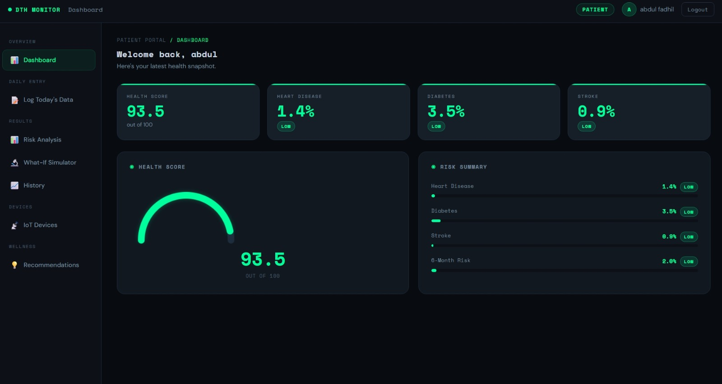

Fig A.2.1 Dashboard

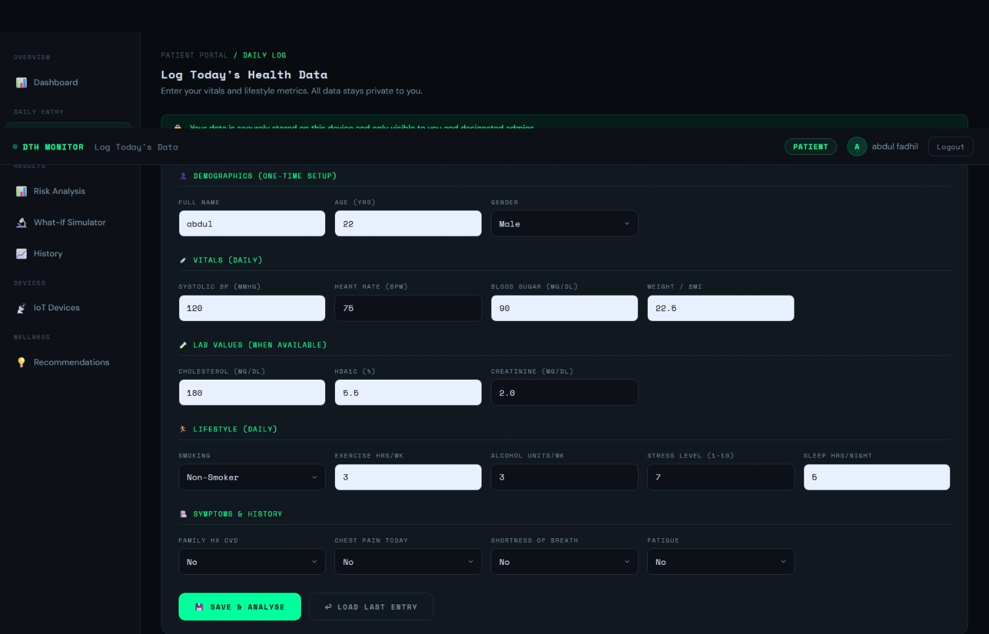
Fig A.2.2 Log Today’s data

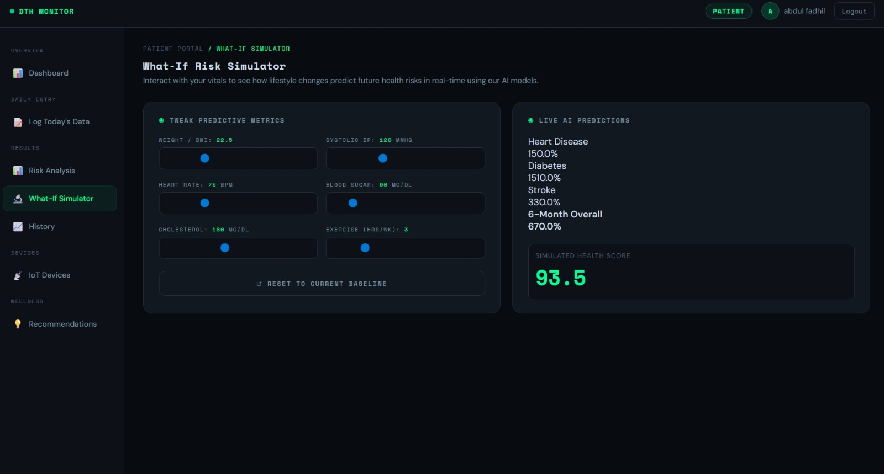

Fig A.2.3 What-if simulator

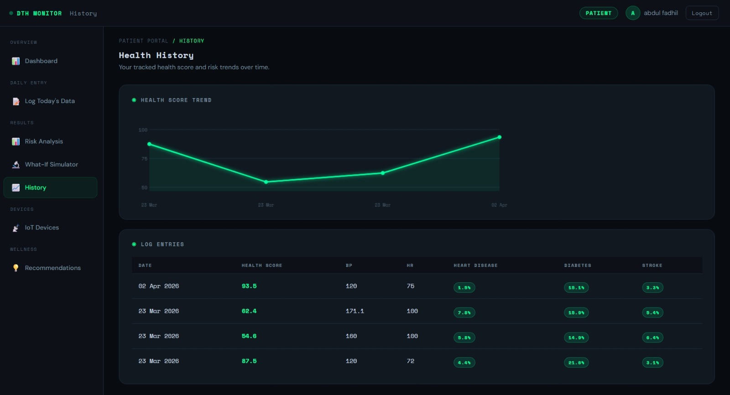

Fig A.2.4 History

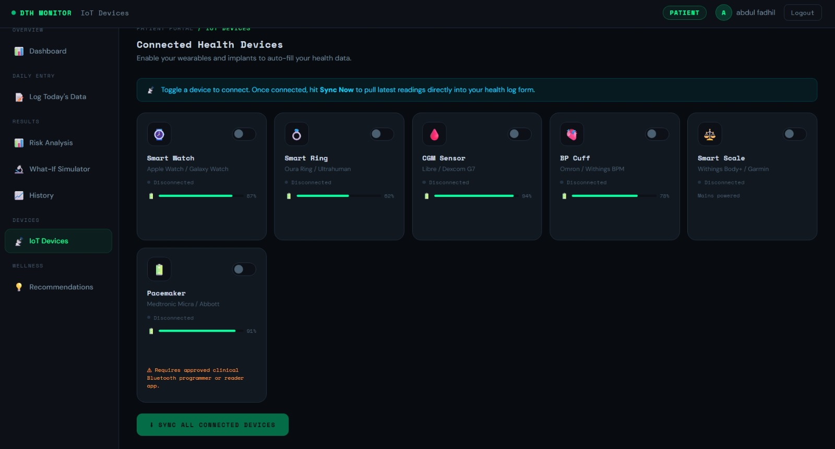

Fig A.2.5 IoT Devices

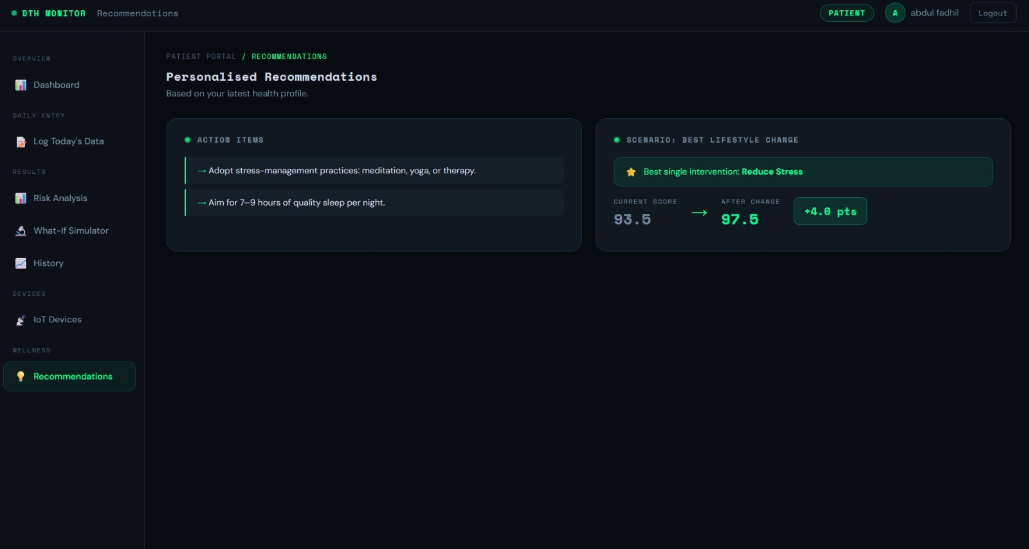

Fig A.2.6 Recommendations

REFERENCES
- K. P. Venkatesh, M. M. Raza, and J. C. Kvedar, “Health digital twins as tools for precision medicine: Considerations for computation, implementation, and regulation,” npj Digital Medicine, vol. 5, art. 150, 2022.
- G. Coorey, G. A. Figtree, D. F. Fletcher, et al., “The health digital twin to tackle cardiovascular disease—a review of an emerging interdisciplinary field,” npj Digital Medicine, vol. 5, art. 126, 2022.
- T. Sun, X. He, X. Song, L. Shu, and Z. Li, “The Digital Twin in Medicine: A Key to the Future of Healthcare?” Frontiers in Medicine, vol. 9, art. 907066, 2022.
- S. Elkefi and O. Asan, “Digital Twins for Managing Health Care Systems,”
Journal of Medical Internet Research, 2022.

- C. Meijer, H.-W. Uh, and S. el Bouhaddani, “Digital Twins in Healthcare: Methodological Challenges and Opportunities,” Journal of Personalized Medicine, vol. 13, no. 10, p. 1522, 2023.
- T. M. Machado and F. T. Berssaneti, “Literature review of digital twin in healthcare,” Heliyon, vol. 9, no. 9, e19390, 2023.
- T. Sun, X. He, and Z. Li, “Digital twin in healthcare: Recent updates and challenges,” Digital Health, vol. 9, 2023.
- B. Sheng, Z. Wang, Y. Qiao, S. Q. Xie, J. Tao, and C. Duan, “Detecting latent topics and trends of digital twins in healthcare: A structural topic model- based systematic review,” Digital Health, vol. 9, 2023.

- A. Vallée, “Digital twin for healthcare systems,” Frontiers in Digital Health, vol. 5, art. 1253050, 2023.
- Scientific Reports, vol. 14, art. 25478, 2024.

- L. El-Warrak and C. M. de Farias, “The State of the Art of Digital Twins in Health—A Quick Review of the Literature,” Computers, vol. 13, no. 9, art. 228, 2024.
- M. Łukaniszyn, Ł. Majka, B. Grochowicz, D. Mikołajewski, and A. Kawala-Sterniuk, “Digital Twins Generated by Artificial Intelligence in Personalized Healthcare,” Applied Sciences, vol. 14, no. 20, art. 9404, 2024.
- M. De Domenico, L. Allegri, G. Caldarelli, et al., “Challenges and opportunities for digital twins in precision medicine from a complex systems perspective,” npj Digital Medicine, vol. 8, art. 37, 2025.
- G. Pellegrino, M. Gervasi, M. Angelelli, and A. Corallo, “A Conceptual Framework for Digital Twin in Healthcare: Evidence from a Systematic Meta- Review,” Information Systems Frontiers, vol. 27, no. 1, pp. 7–32, 2025.
- M. R. Kabir, F. S. Shishir, S. Shomaji, and S. Ray, “Digital twins in healthcare IoT: A systematic review,” High-Confidence Computing, vol. 5, no. 3, art. 100340, 2025.
- V. Riahi, I. Diouf, S. Khanna, J. Boyle, and H. Hassanzadeh, “Digital Twins for Clinical and Operational Decision-Making: Scoping Review,” Journal of Medical Internet Research, vol. 27, e55015, 2025.
- M. Ringeval, F. A. E. Sosso, M. Cousineau, and G. Paré, “Advancing Health Care With Digital Twins: Meta-Review of Applications and Implementation Challenges,” Journal of Medical Internet Research, vol. 27, e69544, 2025.

- M. Tortora, F. Pacchiano, S. F. Ferraciolli, et al., “Medical Digital Twin: A Review on Technical Principles and Clinical Applications,” Journal of Clinical Medicine, vol. 14, no. 2, art. 324, 2025.
- J. D. Iqbal, M. Krauthammer, C. M. Witt, et al., “A consensus statement on the use of digital twins in medicine,” npj Digital Medicine, vol. 8, art. 484, 2025.
- C. Sadée, S. Testa, T. Barba, et al., “Medical digital twins: enabling precision medicine and medical artificial intelligence,” The Lancet Digital Health, vol. 7, no. 7, art. 100864, 2025.
- B. H. Tudor, R. Shargo, G. M. Gray, et al., “A scoping review of human digital twins in healthcare applications and usage patterns,” npj Digital Medicine, vol. 8, art. 587, 2025.

